



|  |  |  |  |
| --- | --- | --- | --- |
| Version | Date | Author | Change Status |
| 1.0 |  |  |  |

**TABLE OF CONTENT**

* ABOUT THIS GUIDE 5
* LEGEND 6
* THE DOCUMENTS – NAME & DESCRIPTION 9
* SESSION SCHEDULE 10
* TOPIC 1 – Introduction to jQuery 11
* SUBTOPIC 1: Participant’s Introduction 11
* SUBTOPIC 2: Ice Breaker Activity 1 12
* SUBTOPIC 3: Ice Breaker Activity 2 13
* SUBTOPIC 4: Session Objectives 14
* TOPIC 2 –Getting Started with jQuery 15
* SUBTOPIC 1: jQuery Introduction 15
* SUBTOPIC 2: jQuery Syntax 16
* SUBTOPIC 3: jQuery Selectors 18
* SUBTOPIC 4: jQuery Events 21
* TOPIC 3 –jQuery Effects 26
* SUBTOPIC 1: jQuery Hide/Show 26
* SUBTOPIC 2: jQuery Fade 27
* SUBTOPIC 3: jQuery slide 32
* SUBTOPIC 4: jQuery Animate 36
* SUBTOPIC 5: jQuery Callback 40
* SUBTOPIC 6: jQuery Chaining 42
* TOPIC 4 –jQuery HTML 45
* SUBTOPIC 1: jQuery Get 45
* SUBTOPIC 2: jQuery Set 49
* SUBTOPIC 3: jQuery Add 52
* SUBTOPIC 4: jQuery Remove 56
* SUBTOPIC 5: jQuery CSS classes 61
* SUBTOPIC 6: jQuery css() 67
* TOPIC 5 –jQuery Traversing 71
* SUBTOPIC 1: jQuery Traversing 71
* SUBTOPIC 2: jQuery Ancestors 73
* SUBTOPIC 3: jQuery Descendants 79
* SUBTOPIC 4: jQuery Siblings 84
* SUBTOPIC 5: jQuery Filtering 88
* TOPIC 6 ¬- Summary 94
* SUBTOPIC 1: Recap 94
* SUBTOPIC 2: Final Tips and Summarization 94

**ABOUT THIS GUIDE**

This Facilitator’s Guide addresses an ILT program of 100 hours duration based on the **ITES Functional Skills Training** course. The program can be divided into 10 sessions.

There should be 25 - 50 participants in this program.

**Please Note:** Some of the group activities may be better facilitated with an even number of participants.

This Facilitator’s Guide will help you give the participants a thorough understanding of the basic functional skills required in the ITES industry.

The features of this guide are as follows:

* It provides hands on experience of the basic Web Design functional skills that are required in the ITES industry.
* It provides references to the page numbers of the ILT version of this program. You can discuss the points as mentioned in this guide when displaying the various screens in the course.
* It includes activities that you can conduct in the class and instructions to carry out the activities.
* It includes a ‘Check Your Understanding’ section which the facilitator can conduct as a quick quiz to test the learner’s understanding of the concepts that are taught in the class.
* It provides the approximate duration of each topic. (However, the duration may vary depending on the length of discussion and/or questions that the participants might have on a particular topic.)
* It includes an explanation for the icons used in the guide. These icons will help you distinctly identify the instructions that need to be followed when explaining a section. The icons are explained on the next page.

**LEGEND**

The following legend explains the various icons used in this guide.

|  |  |
| --- | --- |
| Icon | Description |
|  | Approximate duration of each section |
|  | Project course screen |
|  | Discussion |
|  | Flipchart |
|  | Group Activity |
|  | Activity |
|  | Student’s Guide |
|  | Checklist |
|  | Tips for the Facilitator |
|  | Important |



**CHECKLIST**

* Reach the training venue at least half an hour before the training commences.
* Check that the electrical connections in the room are working.
* Check the temperature of the room and ensure that it is comfortable.
* Keep in place all the required items - white board markers, duster, pens, flip chart sheets, flip chart stand, printouts, etc.
* Check that the computer you are going to display the presentation on is working.
* Check the projector and keep it ready for use.
* Carry the ILT version of the course on your computer, and have it ready for use.
* Ensure that you have gone through the entire course and mapped it to this guide. Be sure of what you need to do on each screen of the course.
* Ensure that all reference documents are kept in a single folder, along with the ILT version of the course for you to easily access during the training session.
* Take print outs of the guides/worksheets for the students and carry the required number of Student’s Guides to the room.
* Print the Facilitator’s Guide document.
* Keep a list of the names of the participants as a reference for yourself to help you identify them.



**PLEASE NOTE:** It is vital that you go through both the course and this guide thoroughly before you conduct your first session. This will increase your confidence while delivering the training.

* **Review** the instructions and activities listed in this Facilitator’s Guide.
* **Ensure** that you have all the teaching aids required for the session. The required teaching aids are:
  1. ILT package for the course
  2. PC and LCD Projector machine and screen
  3. Copies of the **Participant’s Guide** (one for each participant and a copy for yourself)
  4. **Activity** and **Response Sheets** (cut-outs wherever required)
  5. Whiteboard or flipcharts
  6. Stationery items like pens, pencils, whiteboard markers, etc.
* **Review** the ILT version of the course to familiarize yourself with the information provided on each screen. Each screen is referenced in this guide. This will enable you to refer to the relevant screen when explaining it to the participants.



* “**Notes**” sections have been provided at various points in this guide. Note down points that you think are important and need to be further explained in the session.
* **Check** that the computer on which you are going to display the ILT is working and connected to the LCD projector.

# 

**THE DOCUMENTS – NAME & DESCRIPTION**

1. **ITES_WebDesign_jQuery_GettingStarted_.pptx**: This is the ILT version of the course that should be used for the session.
2. **ITES_WebDesign_jQuery_GettingStarted_Participant'sGuide.docx:** This is the Participant’s Guide for the session.

[**Please Note:** Distribute this document After discussing the Program Schedule (Keep a copy of the schedule on the Flipchart for reference)].

**SESSION SCHEDULE**

|  |  |  |
| --- | --- | --- |
| Topic | Sub-topic | Duration in minutes |
| 1. Introduction to jQuery | * Participant’s Introduction * Ice Breaker Activity 1 * Ice Breaker Activity 2 * Session Objectives | 10 minutes |
| 1. Getting Started with jQuery | * jQuery Introduction * jQuery Syntax * jQuery Selectors * jQuery Events | 20 minutes |
| 1. jQuery Effects | * jQuery Hide/Show * jQuery Fade * jQuery Slide * jQuery Animate * jQuery Callback * jQuery Chaining | 40 minutes |
| 1. jQuery HTML | * jQuery Get * jQuery Set * jQuery Add * jQuery Remove * jQuery CSS Classes * jQuery css() | 60 minutes |
| 1. jQuery Traversing | * jQuery Traversing * jQuery Ancestors * jQuery Descendants * jQuery Siblings | 40 minutes |
| 1. Summarization | * Summary points | 10 minutes |
| 1. Check Your Understanding |  |  |
| Total duration | | 180 minutes |



Present the program schedule for the session. Begin the session with a discussion on the detailed structure of the program and the topics to be covered here. (You can copy the schedule table into a PowerPoint presentation to project the schedule on the screen.)

* **NOTE:** Due to the nature of the training, we have not marked the breaks in the schedule. Thus, the total time for the session is approximately 3 hours.   
  Please distribute these breaks as per your discretion.



* Distribute the following to the participants:
* ITES_WebDesign_jQuery_GettingStarted_Participant'sGuide.docx (Printouts)
* Pens
* Notepads

# 

# 

**SUBTOPIC 1: Participant’s Introduction**

**TOPIC 1 – Introduction TO jQuery**

Project the ILT course.



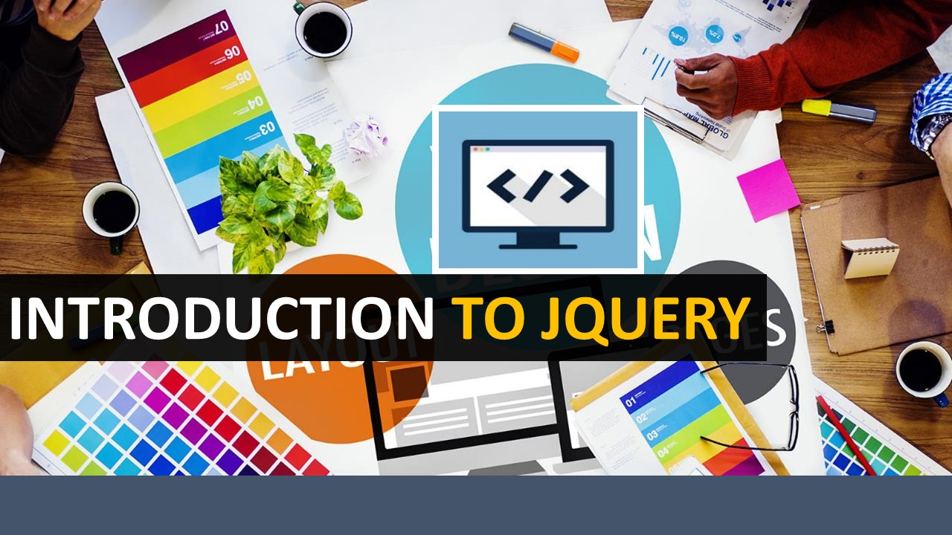

* Play the intro animation. Welcome the participants to the ILT Session on **ITES** - **Basic Functional Skills–jQuery**by saying “Welcome to the course on jQuery. Today, we will discuss about the jQuery and the basic concepts associated with it.”



* Introduce yourself to the participants. Share your name, and a brief professional profile, including: designation, tenure in the organization, domain of work, etc. (especially if most of the participants are unknown to you.)
* Now, have the participants take part in the activity described below.
* **NOTE:** You can either use your own idea/concept to do this, or use one of these activities. We are assuming that the participants by now know each other, and therefore, there’s no need for any introductions, etc.

**SUBTOPIC 2: Icebreaker activity 1**

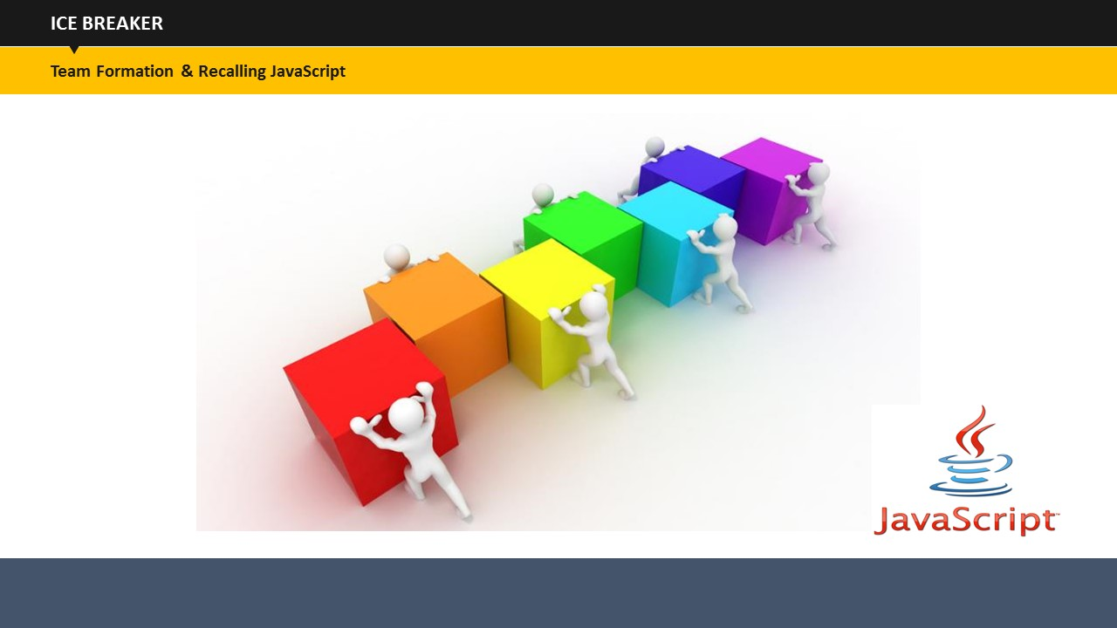

**Do:**

Divide the class into 4 different teams and name them as Team A, Team B, Team C and Team D. The objective is to let them recall what they have learnt in JavaScript.

**Say:**

Discuss the things that you have learned so far in JavaScript. You have 5 minutes to discuss and make note of that within the group.

**Do:**

Call a student from one group and ask him to introduce his group members. Ask him to write any three concepts on the flip chart that they found interesting in JavaScript.

**Do:**

Similarly call a member from each team one by one and ask them to introduce their team members and two more things to what have learned in JavaScript. So, each of the four teams will add two concepts to what has been written by the member of Team A.

**Say:**

Great! This means you remember a lot from what you have been taught in the previous class.

**Say:**

Now, we will go ahead with the introduction jQuery. But before we proceed, let’s see what you all understand by term “jQuery”.

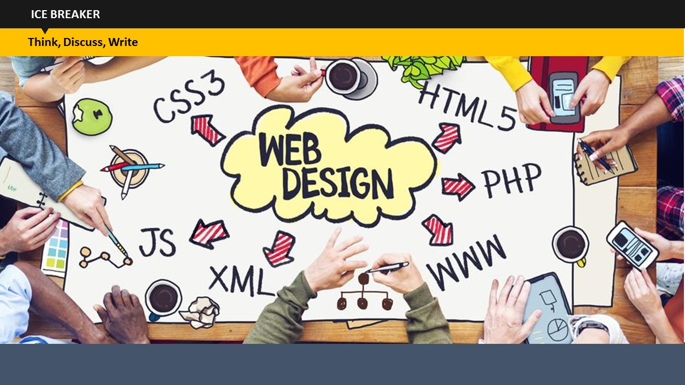

**SUBTOPIC 3: Icebreaker activity 2**

**Do:**

Once they are done with the introduction part, ask them to go back and remain in groups. Provide notepads and pens to each group.

**Say:**

What is jQuery? Is it related to JavaScript? You may have many questions in your mind or you may have some basic knowledge about it. So, you need to write as many keywords as you know related to jQuery. Whatever strikes your mind linked with jQuery, just note it down. You are free to discuss things within the team and then write within 5 minutes.

**Do:**

Once they are done with this, ask any member from each team to speak up what they have written. As the student speaks up the keywords, just write down those on the flipchart.

When every keyword has been written on the board, the facilitator needs to remove redundant & irrelevant keywords. Now, arrange the relevant keywords in the order that you are going to discuss them in the course. Give them just a brief overview that those are the concepts that will be covered in the training.

**Say:**

We will discuss these keywords during the training.

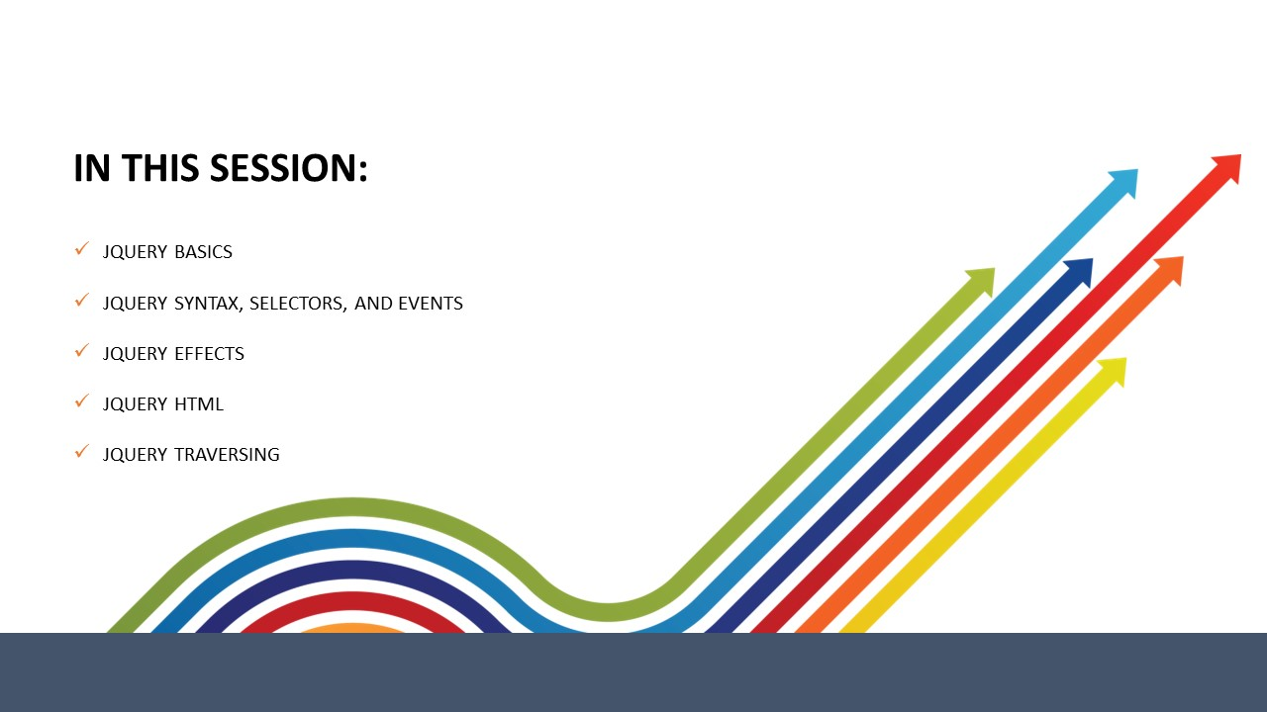

**SUBTOPIC 4: IN THIS SESSION – SESSION OBJECTIVES**

**Say:**

Let us review the objectives for the session today. This will help you understand what tasks you will be able to perform After completing this session.

* 1. **Say:** In this session, you will be introduced to jQuery fundamentals, wherein we will learn the jQuery Syntax, selectors and events.
  2. **Say:** Next, we will discuss jQuery effects, wherein we will understand various jQuery effects, such as hide/show, fade, slide, animate, callback, chaining.
  3. **Say:** After that, we will learn jQuery with HTML/CSS. Concepts of set, get, add, remove, css classes and css(() methods woill be discussed.
  4. **Say:** And lastly, we will learn the jQuery traversing in which we will learn about how to traverse jQuery ancestors, descendants, and siblings, and also will learn how to filter them on basis of conditions.

# 

**Topic 2: Getting started with jQuery**

# 

## 

**SUBTOPIC 1: jQuery Introduction**

**Say:** Before getting started, let us have a quick overview of jQuery. You are already aware of HTML, CSS, and JavaScript, which is great.

**Say:**

jQuery, in reality, is JavaScript itself. The only difference is that JavaScript is a programming language while jQuery is a framework built with JavaScript to aid web developers in their tasks.

**Say:**

jQuery is a lightweight JavaScript library that was designed to make the JavaScript programming simpler and better. It converts a lot of multi-line JavaScript codes into simple methods, which can be called with a single line of code.

**Say:**

jQuery seems to be the most popular JavaScript framework and also the most extendable. Most organizations on the Web use jQuery, such as Google, Microsoft, IBM, Netflix, etc.

**Adding jQuery to a Page**

**Say:**

You can add jQuery to your web page in two ways. The first way is to download the jQuery from the official Website, jquery.com. The second way is to include it from a Content Delivery Network (CDN), such as Google and Microsoft.

**Downloading jQuery**

**Say:**

There are two downloadable versions of jQuery:

* Production version – this version is best for your live Website because it has been minified and compressed
* Development version – this version is best suited for testing and development. It comprises uncompressed and readable codes

**Say:**

The jQuery library is referenced with HTML ***<script>***tag. Make sure that you keep the tag within the ***<head>*** section.

**jQuery from CDN**

**Say:**

If you do not wish to download and host jQuery yourself, you can include it from a Content Delivery Network, such as Google & Microsoft. To use jQuery from Google or Microsoft, you can use one of the following:

**Google CDN:**

<head>  
<script src="http://ajax.googleapis.com/ajax/libs/jquery/1.11.3/jquery.min.js"></script>  
</head>

**Microsoft CDN:**

<head>  
<script src="http://ajax.aspnetcdn.com/ajax/jQuery/jquery-1.11.3.min.js"></script>  
</head>

## 

**SUBTOPIC 2: jQuery Syntax**

**Say:**

jQuery syntax comprises three elements: a **$** sign to access jQuery, **SELECTORS**to query the HTML elements, and **ACTION,** which is to be performed on the HTML elements.

**Syntax**:

$(selection).action()

**Example:**

$(“p”).show() - shows all <p> elements.

**The Document Ready Event**

**Say:**

Every jQuery code runs within a Document Ready Event. This prevents jQuery code to run before the document is fully loaded. There are some actions that can fail if the document is not ready before it is executed.

**Say:**

You can’t hide an element not created yet or you can’t get the size of an image not loaded yet if the JavaScript runs before the document is loaded, which is why Document Ready Event is used.

**Syntax**:

$(document).ready(function(){

// jQuery methods

});

**Say:** There is an alternate method available for Document ready event

**Syntax**:

$(function(){

// jQuery methods

});

**Say:**

However, for ease of understanding, the former method is easier than the latter.

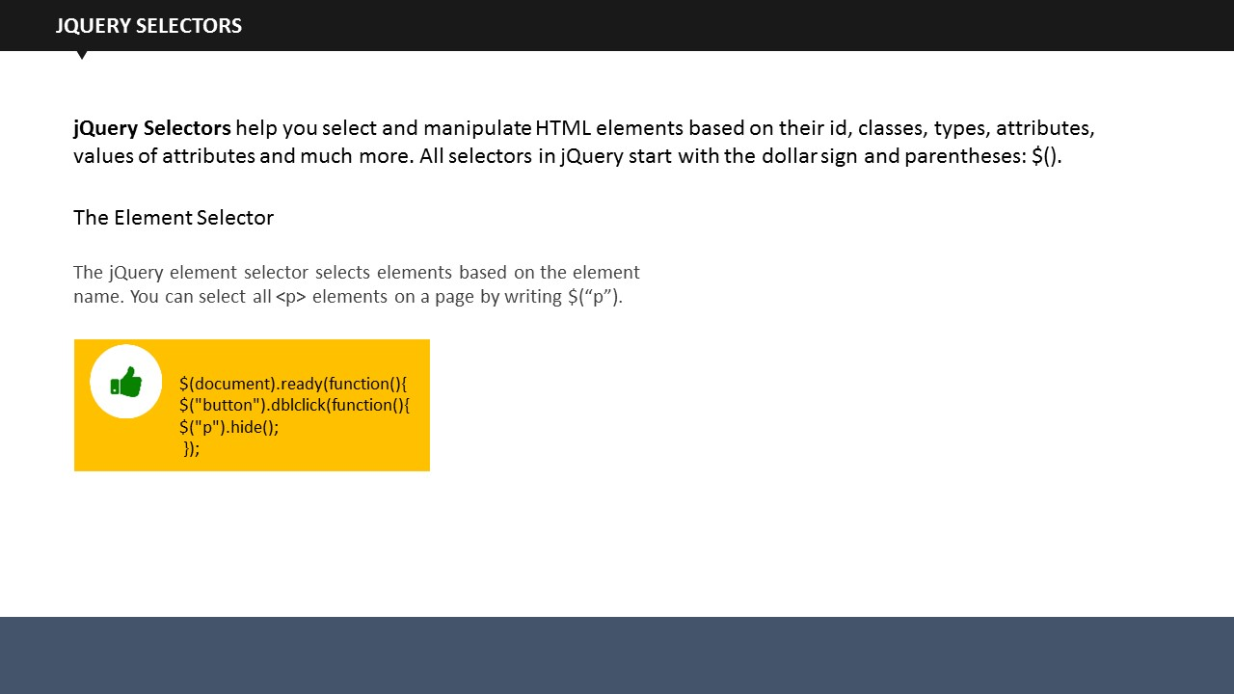

**SUBTOPIC 3: jQuery Selectors**

**Say:** jQuery selectors are an integral part of jQuery library. It allows web developers to find and perform action(s) on HTML elements.

**Say:**

HTML elements are find on basis of their classes, id, attributes, value of attributes, types and much more.

**Say:**

All selectors are written within the brackets and are preceded with a $ sign. Let us see different jQuery selectors.

**The Element Selector**

**Say:**

The element selector selects an element based on its name.

**Example:**

$(document).ready(function(){  
 $("button").dblclick(function(){  
 $("p").hide();  
  });

**Say:**

When a user double clicks a button, all the ***<p>*** elements will be hidden.

**The #id Selector**

**Say:**

The #id selector uses the id attribute of HTML tags. It is used when you want to find a specific, unique element, which is why id should remain unique.

**Example:**

<!DOCTYPE html>

<html>

<head>

<script src="https://ajax.googleapis.com/ajax/libs/jquery/1.11.3/jquery.min.js"></script>

<script>

$(document).ready(function(){

$("button").dblclick(function(){

$("#check").hide();

});

});

</script>

</head>

<body>

<h2>Heading</h2>

<p> Paragraph.</p>

<p id="check"> Another paragraph.</p>

<button> Double click me</button>

</body>

</html>

**Say:**

When the user double clicks on the button, element with id=”check” will be hidden.

**The .class Selector**

**Say:**

The jQuery .class Selector selects elements corresponding to a particular class. We use class name preceded by a period to find elements from that particular class.

**Example:**

<!DOCTYPE html>

<html>

<head>

<script src="https://ajax.googleapis.com/ajax/libs/jquery/1.11.3/jquery.min.js"></script>

<script>

$(document).ready(function(){

$("button").dblclick(function(){

$(".check").hide();

});

});

</script>

</head>

<body>

<h2 class="check">Heading text</h2>

<p class="check">Paragraph text.</p>

<p>another paragraph.</p>

<button> double click me</button>

</body>

</html>

**Say:**

When a user double clicks the button, ***<h2>*** element and ***<p>*** element with class=”check” will be hidden.

|  |  |
| --- | --- |
| Syntax | Description |
| $("*") | Selects all elements |
| $(this) | Selects the current HTML element |
| $("p.intro") | Selects all <p> elements with class="intro" |
| $("p:first") | Selects the first <p> element |
| $("ulli:first") | Selects the first <li> element of the first <ul> |
| $("ulli:first-child") | Selects the first <li> element of every <ul> |
| $("[href]") | Selects all elements with an href attribute |
| $("a[target='_blank']" | Selects all <a> elements with a target attribute value equal to "_blank" |
| $("a[target!='_blank']") | Selects all <a> elements with a target attribute value NOT equal to "_blank" |
| $(":button") | Selects all <button> elements and <input> elements of type="button" |
| $("tr:even") | Selects all even <tr> elements |
| $("tr:odd") | Selects all odd <tr> elements |

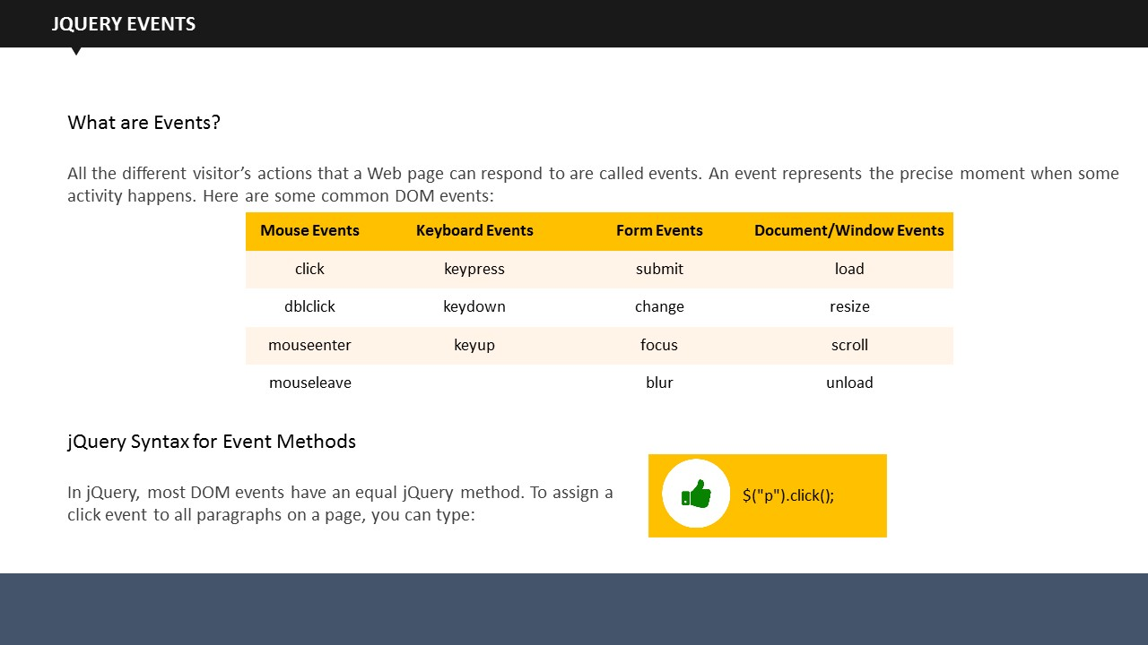

**SUBTOPIC 4: jQuery Events**

**Say:** An Event is an action performed by the visitor on a web page. All the different visitor’s actions that a Web page can respond to are called events. An event represents the precise moment when some activity happens

**Example:**

* Moving a mouse
* Checking a checkbox

**Say:**

On the screen, you can see different mouse, keyboard, form, and windows related events.

**Syntax**:

$("p").click();

**Say:**

This syntax is to assign a click event to all paragraphs on a page. Similarly, we use other events as well.

**Say:**

jQuery has multiple methods to respond to events. Let us see them.

**$(document).ready()**

$(document).ready() is an example of jQuery event method where a function will execute only After the document is fully loaded.

**click()**

The click() method is executed when the user clicks the HTML element.

**Syntax**:

$("p").click(function(){  
 $(this).hide();  
});



* After assigning, you have to define what should happen when that event fires.

**dblclick()**

The dblclick() method is executed when the user double-clicks the HTML element.

**Syntax**:

$("p").dblclick(function(){  
 $(this).hide();  
});

**mouseup()**

The mouseup() method is executed when the left mouse button is released, while the mouse is over the HTML element.

**Syntax**:

$("#p1").mouseup(function(){  
 alert("Mouse up over p1!");  
});

**hover()**

The hover() method combines the mouseenter() and mouseleave() methods. The first function is executed when the mouse enters the HTML element, and the second function is executed when the mouse leaves the HTML element.

**Syntax**:

$("#p1").hover(function(){  
 alert("You entered p1!");  
},  
function(){  
 alert("Bye! You now leave p1!");  
});

**focus()**

The focus() method is executed when the cursor is seen on the form field.

**Syntax**:

$("input").focus(function(){  
 $(this).css("background-color", "#cccccc");  
});

**blur()**

The blur() method is executed when the cursor moves away from the form field.

**Syntax**:

$("input").blur(function(){  
 $(this).css("background-color", "#ffffff");  
});

**on()**

The on() method attaches one or more event handlers for the selected elements. It is used for:

* Attaching a click event to a ***<p>*** element

**Syntax**:

$("p").on("click", function(){  
 $(this).hide();  
});

* Attaching multiple event handlers to a <p> element

**Syntax**:

$("p").on({  
mouseenter: function(){  
 $(this).css("background-color", "lightgray");  
 },   
mouseleave: function(){  
 $(this).css("background-color", "lightblue");  
 },   
 click: function(){  
 $(this).css("background-color", "yellow");  
 }   
});

**The on() Method**

This method allows one or more event handlers for the selected elements.

**Example**

$("p").on({  
    mouseenter: function(){  
        $(this).css("background-color", "gray");  
    },   
    mouseleave: function(){  
        $(this).css("background-color", “red");  
    },   
    click: function(){  
        $(this).css("background-color", "green");  
    }   
});

## 

**TOPIC 2: jQuery Effects**

## 

## 

**SUBTOPIC 1: jQuery Hide/Show**

**Say:** There are a lot of effects that can be added to a web page taking help of jQuery. The hide and show are two of the most basic effects used to hide and show HTML elements respectively.

**Example:**

$(“button”).click(function(){

$(“p”).hide();

On clicking the button, the hide function will hide the entire paragraph. Similarly, the show function will show the hidden paragraph.

**Syntax**:

$(selector).hide(speed, callback);

$(selector).show(speed, callback);

**Say:** The speed parameter (optional) determines how long will take for the effect to take place. It takes values such as “slow, fast, or milliseconds”. The callback parameter is also optional. What it does is it gets executed After hiding or showing is completed. You will learn more about the callback later.

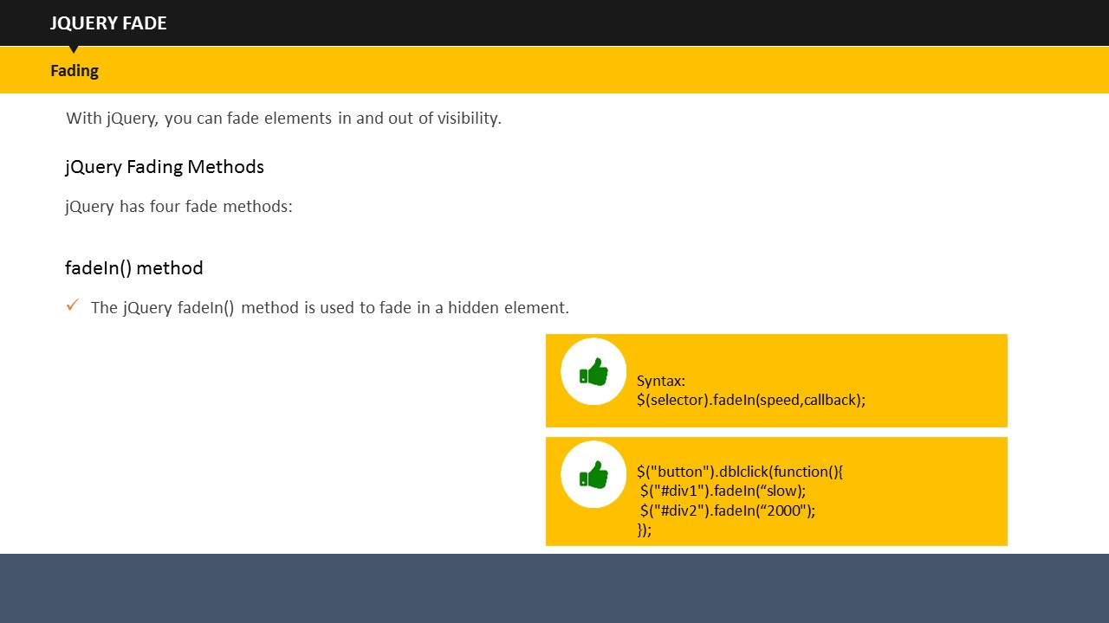**Example:**

$(“button”).click(function(){

$(“p”).hide(1000);

});

On clicking the button, the entire text in the paragraph will be hidden within 1 second (1000 milliseconds).

**jQuery toggle()**

You can toggle between the hide() and show() using the toggle() method. With help of toggle(),the visible elements get hidden and hidden elements become visible..

**Syntax**:

$(selector).toggle(speed, callback);

**Example:**

$(“button”).click(function(){

$(“p”).toggle();

});

**SUBTOPIC 2: jQuery Fade**

**Say:** jQuery provides an option to fade the text, images or graphics present on the web page.

**Say:** You can fade in, fade out, fade toggle, and fade to effects to give your web page a lovely look.

**Say:** for this, there are four methods you can use, which are fadeIn(), fadeOut(), fadeToggle() and fadeTo() methods.

**Say:** Let us see how these methods work.

**jQueryfadeIn() Method**

**Syntax**:

$(selector).fadeIn(speed, callback);

**Say:**

This method fades in a hidden element on page.

Coming on to the syntax, the speed here reflects how much time it would take for elements to show that effect. The callback function will be studied later.

**Example:**

<!DOCTYPE html>

<html>

<head>

<script src="http://ajax.googleapis.com/ajax/libs/jquery/1.11.3/jquery.min.js"></script>

<script>

$(document).ready(function(){

$(“button”).dblclick(function(){

$(“#div1”).fadeIn(“slow”);

$(“#div2”).fadeIn(“2000”);

});

});

</script>

</head>

<body>

<p>Show fadeIn() with various parameters.</p>

<button> Double Click to fade in boxes</button><br><br>

<div id="div1" style="width:80px;height:80px;display:none;background-color:red;"></div><br>

<div id="div2" style="width:80px;height:80px;display:none;background-color:green;"></div><br>

</body>

</html>

**Say:**

In this example, there is a button on whose double click event will fade in two boxes. The first box will appear slowly while the second box will appear After 1 second of the double click event.

**jQuery fadeOut() Method**

**Syntax**:

$(selector).fadeOut(speed, callback);

**Say:**This methods fades out the already visible elements.

**Example:**

<!DOCTYPE html>

<html>

<head>

<script src="http://ajax.googleapis.com/ajax/libs/jquery/1.11.3/jquery.min.js"></script>

<script>

$(document).ready(function(){

$(“button”).dblclick(function(){

$(“#div1”).fadeOut(“slow”);

$(“#div2”).fadeOut(“2000”);

});

});

</script>

</head>

<body>

<p>ShowfadeOut() with various parameters.</p>

<button> Double Click to fade in boxes</button><br><br>

<div id="div1" style="width:80px;height:80px;display:none;background-color:red;"></div><br>

<div id="div2" style="width:80px;height:80px;display:none;background-color:green;"></div><br>

</body>

</html>

**Say:**

In this example, there is a button on whose double click event will fade out two boxes. The first box will fade out slowly while the second box will disappear After 2 seconds of the double click event.

**jQueryfadeToggle() Method**

**Syntax**:

$(selector).fadeToggle(speed, callback);

**Say:**

The fadeToggle() method, as the name suggests, toggles between fadeout() and fadeIn() methods. If the elements are already faded in, it would fade out them, and vice versa.

**Example:**

<html>

<head>

<script src="http://ajax.googleapis.com/ajax/libs/jquery/1.11.3/jquery.min.js"></script>

<script>

$(document).ready(function(){

$("button").dblclick(function(){

$("#div1").fadeToggle(“slow);

$("#div2").fadeToggle("4000");

});

});

</script>

</head>

<body>

<p>Show fadeToggle() with different speed parameters.</p>

<button> Double Click to fade in/fade out boxes</button><br><br>

<div id="div1" style="width:80px;height:80px;background-color:red;"></div>

<br>

<div id="div2" style="width:80px;height:80px;background-color:green;"></div>

<br>

</body>

</html>

**Say:**

In this example, on double clicking the button, the boxes will fade in and fade out asper their initial position.

**jQuery fadeTo() Method**

**Syntax**:

$(selector).fadeTo(speed, opacity, callback);

**Say:**

****The fadeTo() method helps in fading the elements to the given opacity.

* Opacity level is the transparency level of an element. You can set it according to you. It can be set between 0 to 1 where 0 is fully transparent, 0.5 is half transparent, while 1 signifies no transparency.

**Example:**

<!DOCTYPE html>

<html>

<head>

<script src="http://ajax.googleapis.com/ajax/libs/jquery/1.11.3/jquery.min.js"></script>

<script>

$(document).ready(function(){

$("button").dblclick(function(){

$("#div1").fadeTo("slow", 0.15);

$("#div2").fadeTo("slow", 0.65);

});

});

</script>

</head>

<body>

<p> ShowfadeTo() with different parameters.</p>

<button> Double Click to fade boxes</button><br><br>

<div id="div1" style="width:80px;height:80px;background-color:red;"></div><br>

<div id="div2" style="width:80px;height:80px;background-color:green;"></div><br>

</body>

</html>

**Say:**

This example will fade the two given boxes to their respective opacity values. The red box will fade to 0.15 while the green box will fade to 0.65 opacity. Both the boxes will fade to their respective opacity very slowly.

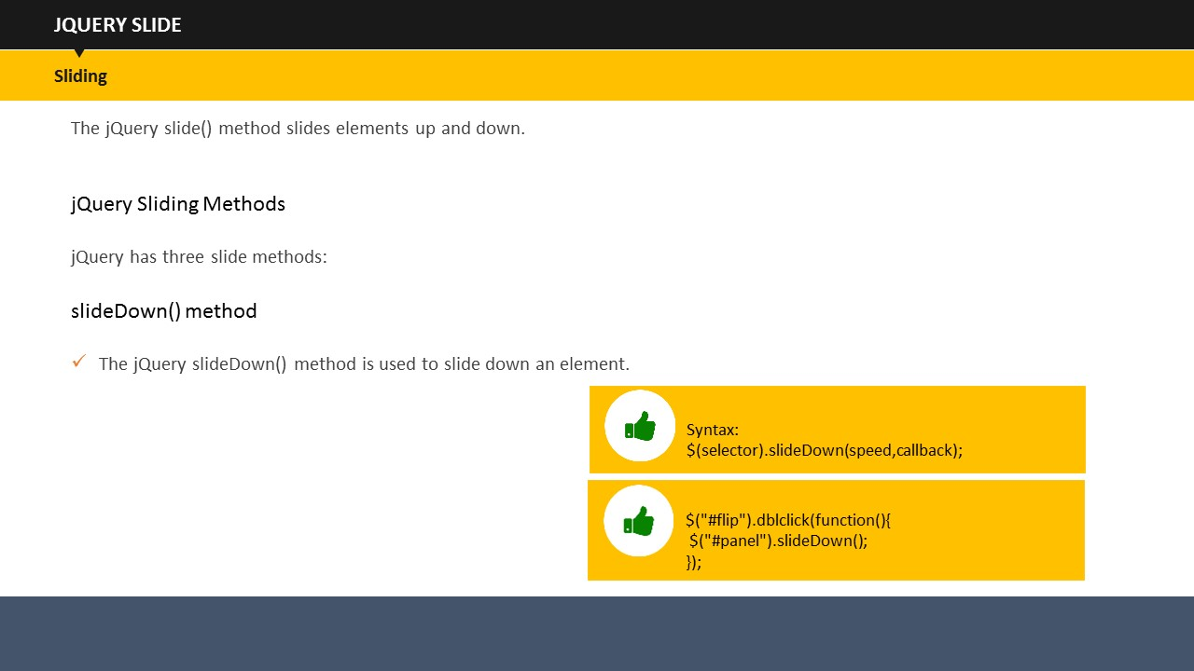

**SUBTOPIC 3: jQuery Slide**

**Say:**

You must have seen sliders on several Websites and must have been greatly impressed by the same.

**Do:**

Elicit responses.

**Say:**

Now you can create that yourself as jQuery makes use of Slide effect which is used to slide up and down the elements.

**Say:**

slideUp(), slideDown(), and slideToggle() are three methods provided in jQuery to achieve the sliding effect.

**Say:**

Let’s see how these methods work.

**jQuery slideUp() Method**

**Syntax:**

$(selector).slideUp(speed, callback);

**Say:**

The slideUp() Method slides up an element.

**Say:**

The say and callback parameter works exactly as we have just studied in previous topics.

**Say:**

Let us see an example now.

**Example:**

<!DOCTYPE html>

<html>

<head>

<script src="http://ajax.googleapis.com/ajax/libs/jquery/1.11.3/jquery.min.js"></script>

<script>

$(document).ready(function(){

$("#flip").dblclick(function(){

$("#panel").slideUp("2000");

});

});

</script>

<style>

#panel, #flip {

padding: 4px;

text-align: center;

background-color: #e5eecc;

border: solid 2px #c3c3c3;

}

#panel {

padding: 60px;

}

</style>

</head>

<body>

<div id="flip">double click to slide up this panel</div>

<div id="panel">Hello User!</div>

</body>

</html>

**Say:**

This example will slide up the panel upon double clicking the flip box. The panel will take two seconds to completely slide up because the speed parameter is set at 2000 milliseconds.

**jQuery slideDown() Method**

**Syntax:**

$(selector).slideDown(speed, callback);

**Say:**

The slideDown() Method slides down an element.

**Say:**

Let us see an example now.

**Example:**

<!DOCTYPE html>

<html>

<head>

<script src="http://ajax.googleapis.com/ajax/libs/jquery/1.11.3/jquery.min.js"></script>

<script>

$(document).ready(function(){

$("#flip").dblclick(function(){

$("#panel").slideDown("2000");

});

});

</script>

<style>

#panel, #flip {

padding: 4px;

text-align: center;

background-color: #e5eecc;

border: solid 2px #c3c3c3;

}

#panel {

padding: 60px;

}

</style>

</head>

<body>

<div id="flip">double click to slide down this panel</div>

<div id="panel">Hello User!</div>

</body>

</html>

**Say:**

This example will slide down the panel when the flip box is double clicked. This panel will again take two seconds to completely slide up because the speed parameter is set at 2000 milliseconds.

**jQuery slideToggle()**

$(selector).slideToggle(speed, callback);

**Say:**

The slideToggle() method, as the name suggests, toggles between slideDown() and slideUp() methods. If the element is already slid down, it would slid them up, and vice versa.

## 

**SUBTOPIC 4: jQuery Animate**

**Say:**

jQuery lets you create custom animations with the help of jQuery animate() method.

**Syntax**:

$(selector).animate({params}, speed, callback);

* The params parameter defines which CSS elements to animate.

**Example:**

<!DOCTYPE html>

<html>

<head>

<script src="http://ajax.googleapis.com/ajax/libs/jquery/1.11.3/jquery.min.js"></script>

<script>

$(document).ready(function(){

$("button").dblclick(function(){

$("div").animate({right: '400px'});

});

});

</script>

</head>

<body>

<button>Double click to begin animation</button>

<div style="background:#98bf21;height:100px;width:100px;position:absolute;"></div>

</body>

</html>

**Say:**

This example moves the***<div>***element to its right till it reaches its right property of 250 px.

* The default position of HTML elements is static, which means they cannot be moved. Therefore, before animating your page, make sure that you change the CSS position property to fixed, absolute, or relative.

**Say:**

We can use a lot of properties with animate() method. Let us see the different properties now.

**jQuery animate()- manipulate multiple properties using relative values**

**Example:**

<!DOCTYPE html>

<html>

<head>

<script src="http://ajax.googleapis.com/ajax/libs/jquery/1.11.3/jquery.min.js"></script>

<script>

$(document).ready(function(){

$("button").dblclick(function(){

$("div").animate({

right: '350px',

height: '+=250px',

width: '+=250px'

});

});

});

</script>

</head>

<body>

<button>double click here to begin the animation</button>

<div style="background:#98bf21;height:100px;width:100px;position:absolute;"></div>

</body>

</html>

This example animates a ***<div>***element by manipulating multiple properties using relative values. On double clicking the button, the box will start to move to its right till it reaches its right property of 350 px, while its height and width will correspondingly grow to 250 px each.

**Say:**

The “+=” means that the ***<div>***element will continue to increase in its width and height by a factor of 250 px each, every time you double click the button.

**jQuery animate() – using pre-defined values**

**Example:**

<!DOCTYPE html>

<html>

<head>

<script src="http://ajax.googleapis.com/ajax/libs/jquery/1.11.3/jquery.min.js"></script>

<script>

$(document).ready(function(){

$("button").dblclick(function(){

$("div").animate({

height: 'toggle'

});

});

});

</script>

</head>

<body>

<button>double click here for animation to begin</button>

<div style="background:#98bf21;height:100px;width:100px;position:absolute;"></div>

</body>

</html>

**Say:**

This example shows a ***<div>*** element. On double clicking this element, the element will disappear. When you click it again, it will reappear again. This is because of the toggle condition which is associated with its height.

**jQuery Stop**

**Say:**

jQuery stop() method stops all the effects before its completion. It stops the slide, fade and animation effects.

**Syntax**:

$(selector).stop(stopAll, goToEnd);

**Say:**

The stopAll parameter is optional. It specifies whether the animation queue should be cleared or not. Its default value is false.

**Say:**

The other optional goToEnd parameter determines whether to complete the ongoing animation immediately or not. Its default value is also false.

## 

**SUBTOPIC 5: jQuery Callback**

**Say:**

Like many other languages, JavaScript executes its code by following line by line execution. But there can be instances when one effect can run longer than the effect that is to follow it. In such cases, we may not get the desired output or even errors. callback() method is used to resolve this very problem. It is executed only After the current effect is completed. Let us see an example to understand it.

**Example:**

<!DOCTYPE html>

<html>

<head>

<script src="http://ajax.googleapis.com/ajax/libs/jquery/1.11.3/jquery.min.js"></script>

<script>

$(document).ready(function(){

$("button").dblclick(function(){

$("p").hide("slow", function(){

alert("The paragraph is hidden");

});

});

});

</script>

</head>

<body>

<button>Hide</button>

<p>This is a test paragraph.</p>

</body>

</html>

**Say:**

In this example, there is a paragraph which gets hidden upon double clicking the button. The hiding effect will take one second. When the effect finishes, an alert message pops up which reads “the paragraph is hidden”.

**Say:**

Suppose, if we have not used the callback() method, our code would look like this:

$("button").click(function(){

$("p").hide(1000);

alert("The paragraph is now hidden");

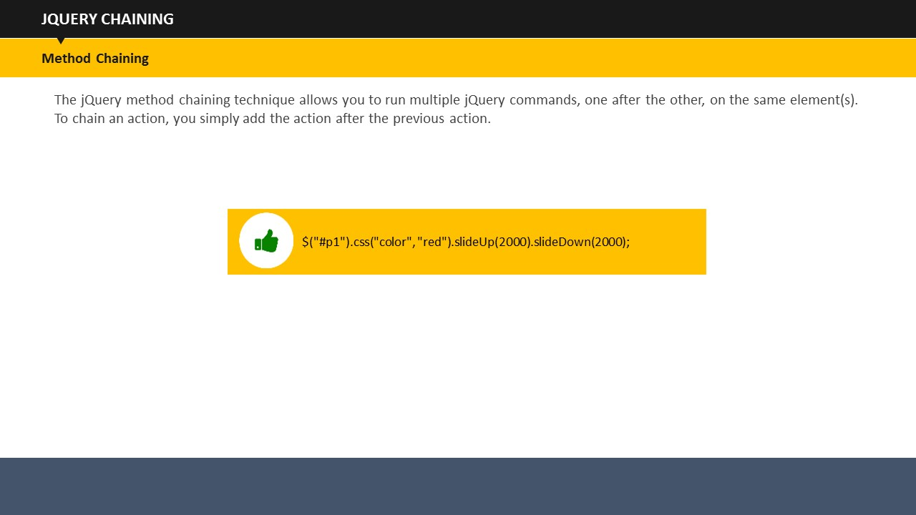 });

In this example, the alert message would appear straight After the double click, which is not the desired outcome.

**Say:**

We use callback() method to make sure that one effect will come in to play only After its preceding effect has fully taken place.

**Say:**

**SUBTOPIC 6: jQuery Chaining**

Up until now, we have been using jQuery statements one After the other. This gets a little too long. Resolving this, jQuery provides an option of Chaining in which we can run more than one jQuery methods on the same element.

**Say:**

All you need to do is to append a method to the previous method. jQuery provides an option to write chained codes either in a single line or you can spread them through multiple lines.

**Say:**

Let us see an example

**Example:**

<!DOCTYPE html>

<html>

<head>

<script src="http://ajax.googleapis.com/ajax/libs/jquery/1.11.3/jquery.min.js"></script>

<script>

$(document).ready(function(){

$("button").dblclick(function(){

$("#p1"). slideUp(2000).slideDown(2000);

});

});

</script>

</head>

<body>

<p id="p1">Chaining example</p>

<button>Click me</button>

</body>

</html>

**Say:**

The example shows a paragraph with text “chaining example” with a button underneath. When you double click the button, the paragraph will slide up for two seconds hiding the paragraph and then it will automatically slid down revealing the paragraph.

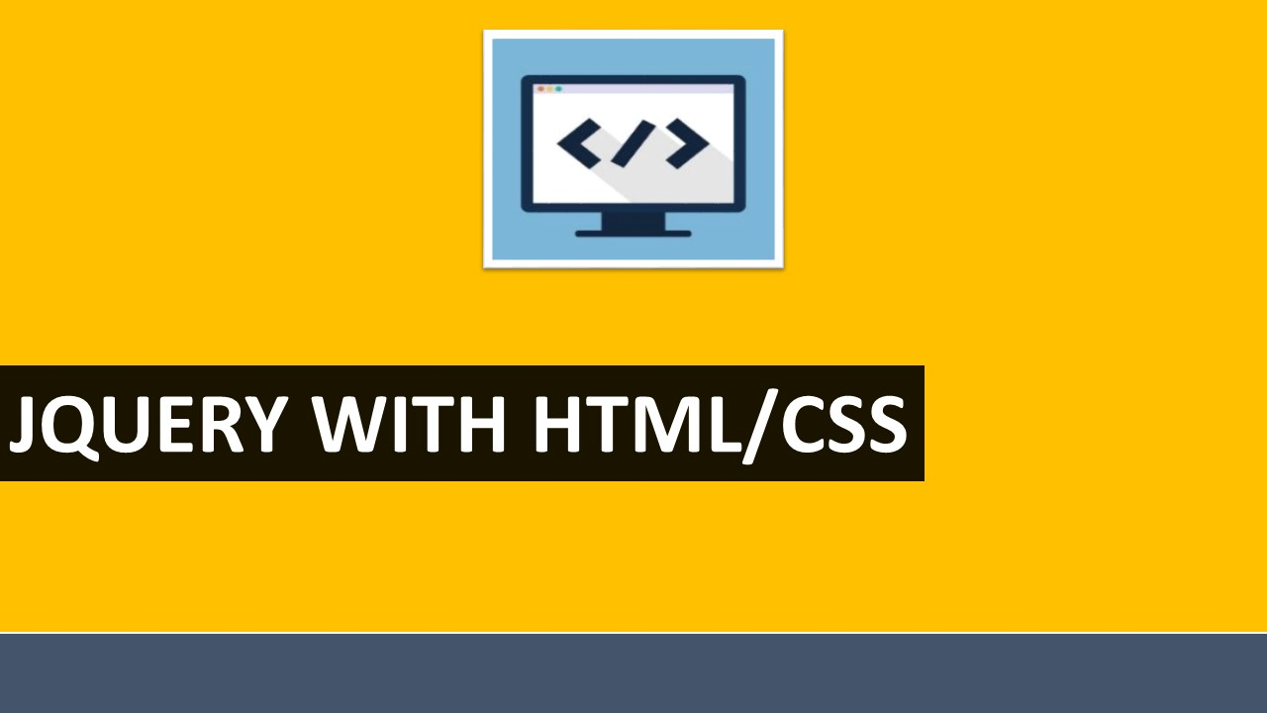

**TOPIC 3: jQuery with HTML/CSS**

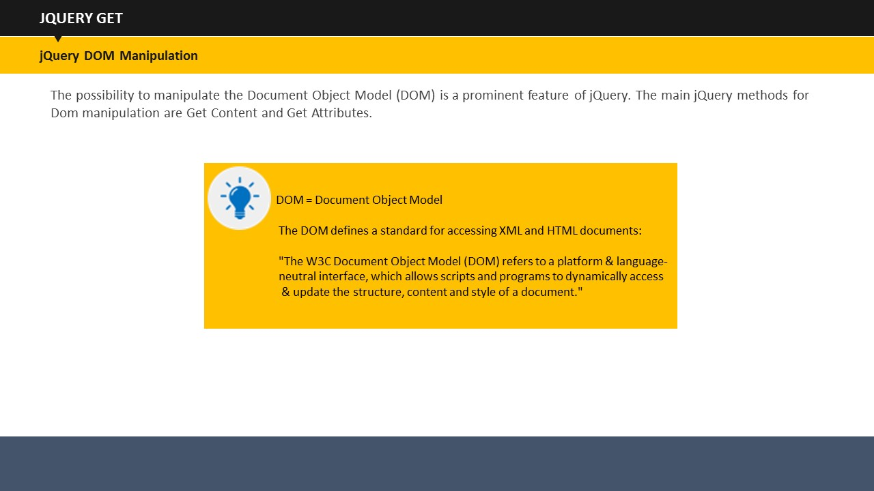

**Say:**

One very prominent feature of jQuery is the possibility to manipulate the Document Object Model (DOM). DOM defines a standard to access XML and HTML documents. Let us see important jQuery methods for DOM manipulation.

**Get Content- text(), html(), and val()**

* Text() – it returns the text content of the selected elements
* Html() – it returns the content of the selected elements
* Val() – it returns the value of form fields

**Example:**

<!DOCTYPE html>

<html>

<head>

<script src="http://ajax.googleapis.com/ajax/libs/jquery/1.11.3/jquery.min.js"></script>

<script>

$(document).ready(function(){

$("#bttn1").dblclick(function(){

alert("Text: " + $("#check").text());

});

$("#bttn2").dblclick(function(){

alert("HTML: " + $("#check").html());

});

});

</script>

</head>

<body>

<p id="check">there is some <b>bold</b> text here.</p>

<button id="bttn1">Display Text</button>

<button id="bttn2">Display HTML</button>

</body>

</html>

**Say:**

This example displays two buttons and a paragraph. When you double click on the “Display Text” button, the script would display the entire text within the ***<p>*** element sans ***<b>***and***</b>***tags. When you double click “Display HTML button, the same text will be shown including the tags.

**Say:**

Let us now see the example of val() method.

**Example:**

<!DOCTYPE html>

<html>

<head>

<script src="http://ajax.googleapis.com/ajax/libs/jquery/1.11.3/jquery.min.js"></script>

<script>

$(document).ready(function(){

$("button").dblclick(function(){

alert("Value: " + $("#tcheck").val());

});

});

</script>

</head>

<body>

<p>Name: <input type="text" id="check" value="MohdShafi"></p>

<button>Display Value</button>

</body>

</html>

**Say:**

This example fetches the value from the form field. In this case, the value that will be shown is Mohd Shafi.

**Get attributes- attr()**

**Say:**

The attr() method returns the attribute values.

**Example:**

<!DOCTYPE html>

<html>

<head>

<script src="http://ajax.googleapis.com/ajax/libs/jquery/1.11.3/jquery.min.js"></script>

<script>

$(document).ready(function(){

$("button").dblclick(function(){

alert($("#abc").attr("href"));

});

});

</script>

</head>

<body>

<p><a href="http://www.abc123.com" id="abc">abc123.com</a></p>

<button>Displayhref Value</button>

</body>

</html>

**Say:**

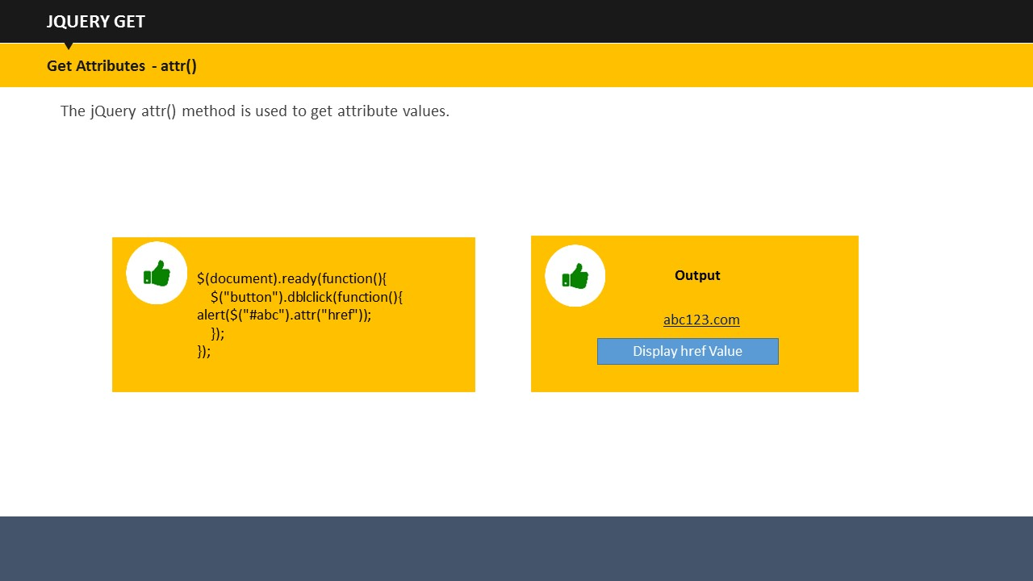This example fetches the href value of the Website.

**SUBTOPIC 2: jQuery Set**

**Set Content- text(), html(), and val()**

* Text() – it sets the text content of the selected elements
* Html() – it sets the content of the selected elements
* Val() – it sets the value of form fields

**Example:**

<!DOCTYPE html>

<html>

<head>

<script src="http://ajax.googleapis.com/ajax/libs/jquery/1.11.3/jquery.min.js"></script>

<script>

$(document).ready(function(){

$("#btn1").dblclick(function(){

$("#check1").text("Hey users");

});

$("#btn2").dblclick(function(){

$("#tcheck2").html("<b>Hey users!</b>");

});

$("#btn3").dblclick(function(){

$("#tcheck3").val("Dolly Dew");

});

});

</script>

</head>

<body>

<p id="check1">This is a test paragraph.</p>

<p id="check2">This is another test paragraph.</p>

<p>Input field: <input type="text" id="check3" value="Mickey up"></p>

<button id="btn1">Set Text</button>

<button id="btn2">Set HTML</button>

<button id="btn3">Set Value</button>

</body>

</html>

**Say:**

There are three buttons – Set Text, Set HTML and Set Value- along with two paragraphs and one form field.

Say:

On double clicking the “Set Text” button, paragraph 1 will be replaced with the given text.

On double clicking the “set HTML”, paragraph 2 will be replaced with the given text.

On double clicking the “Set Value” button, form value will get changed as well.

**Set attributes- attr()**

**Say:**

Similarly, you can change the href as well as the title using attr() method.

**Example:**

<!DOCTYPE html>

<html>

<head>

<script src="http://ajax.googleapis.com/ajax/libs/jquery/1.11.3/jquery.min.js"></script>

<script>

$(document).ready(function(){

$("button").dblclick(function(){

$("#abc").attr({

"href" : "http://www.abc123.com/456",

"title" : "ABC 123 456"

});

});

});

</script>

</head>

<body>

<p><a href="http://www.abc123.com" title="abc 123" id="abc">abc123.com</a></p>

<button> sethref and title</button>

<p>Point to the link to see the changed href attribute and newly set title value.</p>

</body>

</html>

**Say:**

With the help of attr(), we have changed the href attribute and also reset the title of the URL.

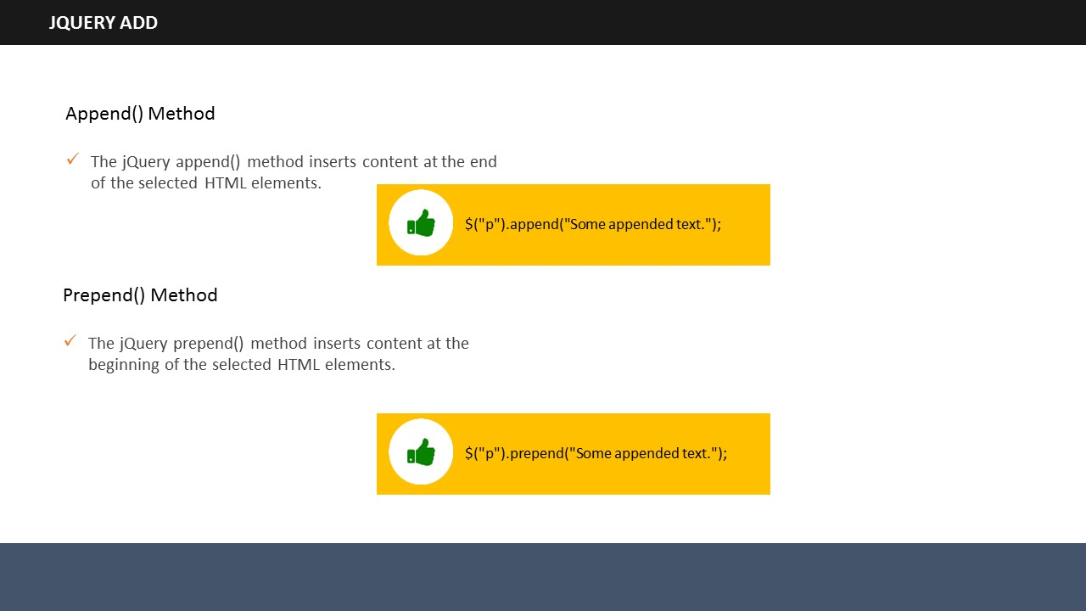

**SUBTOPIC 3: jQuery- Add**

**Say:**

With jQuery, it is very easy to add new elements anywhere on the page. We use four methods to do that.

* append()
* prepend()
* After()
* before()

**Say:**

Let us take a look at these methods.

**append**()

**Say:** append() method is used to add a new element at the end of selected HTML elements.

**prepend**():

**Say:**

prepend() method is used to add a new element at the end of beginning of selected HTML elements.

**before**()

**Say:**

before() method is used to add a new element before selected HTML elements.

**After**()

**Say:**

After () method is used to add a new element After selected HTML elements.

**Say:**

You can add several elements using these methods. You can generate new elements with any one of the HTML, jQuery, or DOM.

**before() and After()**

**Example:**

<!DOCTYPE html>

<html>

<head>

<script src="http://ajax.googleapis.com/ajax/libs/jquery/1.11.3/jquery.min.js"></script>

<script>

functionappendText() {

var text1 = "<p>Hi.</p>";

var text2 = $("<p></p>").text("Hi.");

var text3 = document.createElement("p");

text3.innerHTML = "Hi";

$("body").append(text1, text2, text3);

}

</script>

</head>

<body>

<p>Hello users.</p>

<button ondblclick="appendText()">Append text</button>

</body>

</html>

**Say:**

In this example, three variable with text “Hi” are created using each of HTML, jQuery, and DOM. These variables are then appended After the paragraph “Hello users” After double clicking the button.

**Say:**

This works same for prepend() as well.

**before() and After()**

**Example:**

<!DOCTYPE html>

<html>

<head>

<script src="http://ajax.googleapis.com/ajax/libs/jquery/1.11.3/jquery.min.js"></script>

<script>

functionAfterText() {

var text1 = "<b>I </b>";

var text2 = $("<i></i>").text("like ");

var text3 = document.createElement("b");

text3.innerHTML = "programming!";

$("img").After(text1, text2, text3);

}

</script>

</head>

<body>

<imgsrc="/images/w3jquery.gif" alt="jQuery" width="100" height="140">

<p>Double click the button to insert text After the image.</p>

<button ondblclick="AfterText()">Insert After</button>

</body>

</html>

**Say:**

This example inserts text After an image. The same procedure applies for before() method as well.

## 

**SUBTOPIC 4: jQuery- Remove**

**Say:**

After learning how to add elements, it is time to know about how to remove them. jQuery provides two methods to remove elements – remove() and empty(). Let’s have a look at each of them.

**jQuery remove() method**

**Say:**

The remove() method, as its name suggests, removes selected elements along with their child elements.

**Example:**

<!DOCTYPE html>

<html>

<head>

<script src="https://ajax.googleapis.com/ajax/libs/jquery/1.11.3/jquery.min.js"></script>

<script>

$(document).ready(function(){

$("button").dblclick(function(){

$("#div1").remove();

});

});

</script>

</head>

<body>

<div id="div1" style="height:200px;width:400px;border:2px solid black;background-color:red;">

This is demo text in the div.

<p>This is a line in the div.</p>

<p>This is another line in the div.</p>

</div>

<br>

<button>Remove div element</button>

</body>

</html>

**Say:**

In this example, you can see there is a div comprising of three lines. When you double click on the “remove div element”, the entire div will be removed. Here, the selected element was div and the paragraphs were its child elements, all of which are removed due to the remove() method.

**jQuery empty() method**

**Say:**

The empty() method removes child elements of the selected elements.

**Example:**

<!DOCTYPE html>

<html>

<head>

<script src="https://ajax.googleapis.com/ajax/libs/jquery/1.11.3/jquery.min.js"></script>

<script>

$(document).ready(function(){

$("button").dblclick(function(){

$("#div1").empty();

});

});

</script>

</head>

<body>

<div id="div1" style="height:200px;width:400px;border:1px solid black;background-color:red;">

This is demo text in the div.

<p>This is a line in the div.</p>

<p>This is another line in the div.</p>

</div>

<br>

<button>Empty the div element</button>

</body>

</html>

**Say:**

In this example, everything is same, except the method, which is empty() here. When you double click on the “Empty the div element”, only the child elements of div will be removed, and not the div.

**Removing the elements After filtering them**

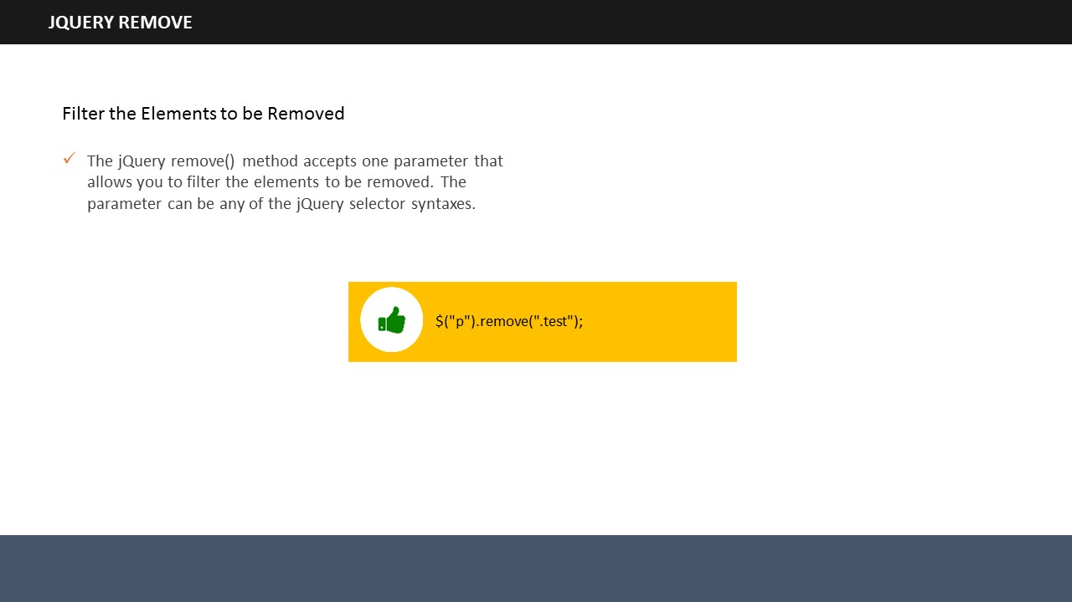

**Say:**

You can remove elements by filtering as well. remove() method accepts parameter through which you can do the same.Let us see an example.

**Example:**

<!DOCTYPE html>

<html>

<head>

<script src="https://ajax.googleapis.com/ajax/libs/jquery/1.11.3/jquery.min.js"></script>

<script>

$(document).ready(function(){

$("button").dblclick(function(){

$("p").remove(".check, .example");

});

});

</script>

<style>

.check {

color: yellow;

font-size: 25px;

}

.example {

color: red;

font-size: 30px;

}

</style>

</head>

<body>

<p>This is some text.</p>

<p class="check">This is class="check".</p>

<p class="check">This is class="test".</p>

<p class="example">This is class="example".</p>

<button>Remove elements with class="check" and class="example"</button>

</body>

</html>

**Say:**

In this example, you can see we remove all elements containing class= “check and class= “example”.

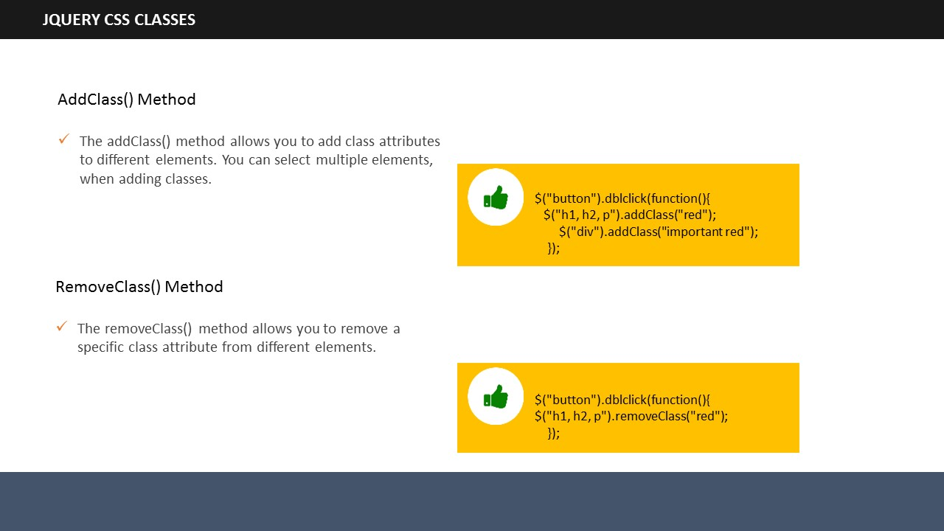**Say:**

**SUBTOPIC 5: jQuery- CSS classes**

jQuery has simplified manipulating the CSS of elements. It has several methods through which we can manipulate the CSS. Let’s have a look.

* addClass()
* removeClass()
* toggleClass()

**Example:**

.important {

font-weight : bold;

font-size : large;

}

.red {

color : red;

}

**Say:**

This is a stylesheet that we are going to use to understand addClass(), removeClass(), and toggleClass().

**addClass()**

**Say:**

Let us see an example.

**Example:**

<!DOCTYPE html>

<html>

<head>

<script src="https://ajax.googleapis.com/ajax/libs/jquery/1.11.3/jquery.min.js"></script>

<script>

$(document).ready(function(){

$("button").dblclick(function(){

$("h1, h2, p").addClass("red");

$("div").addClass("important red");

});

});

</script>

<style>

.important {

font-weight: bold;

font-size: large;

}

.red{

color: red;

}

</style>

</head>

<body>

<h1>Heading 1</h1>

<h2>Heading 2</h2>

<p>This is a demo paragraph.</p>

<p>This is another demo paragraph.</p>

<div>This is demo text!</div><br>

<button>Add classes </button>

</body>

</html>

**Say:**

This example adds “important” as well as “red CSS” classes to the elements. The class important is added to heading 1, heading 2 and paragraph while both the classes are added to the ***<div>*** elements.

**removeClass()**

**Say:**

removeClass() method removes class attributes from the elements. Let us see an example.

**Example:**

<!DOCTYPE html>

<html>

<head>

<script src="https://ajax.googleapis.com/ajax/libs/jquery/1.11.3/jquery.min.js"></script>

<script>

$(document).ready(function(){

$("button").dblclick(function(){

$("h1, h2, p").removeClass("red");

});

});

</script>

<style>

.important {

font-weight : bold;

font-size : large;

}

.red {

color : red;

}

</style>

</head>

<body>

<h1 class="red">Heading 1</h1>

<h2 class="red">Heading 2</h2>

<p class="red">This is a demo paragraph.</p>

<p>This is another demo paragraph.</p>

<button>Remove class from elements</button>

</body>

</html>

**Say:**

This example displays two headings and two paragraphs. Both headings and the first paragraph use the class red. removeClass() method removes the red class attribute from the headings and the first paragraph.

**toggleClass()**

**Say:**

You can toggle between adding and removing CSS classes with the help of toggleClass() method. Let us see an example.

**Example:**

<!DOCTYPE html>

<html>

<head>

<script src="https://ajax.googleapis.com/ajax/libs/jquery/1.11.3/jquery.min.js"></script>

<script>

$(document).ready(function(){

$("button").dblclick(function(){

$("h1, h2, p").toggleClass("red");

});

});

</script>

<style>

.red {

color: red;

}

</style>

</head>

<body>

<h1>Heading 1</h1>

<h2>Heading 2</h2>

<p>This is a demo paragraph.</p>

<p>This is another demo paragraph.</p>

<button>Toggle</button>

</body>

</html>

**Say:**

This example illustrates the toggleClass(). We add and remove the class red on the double click event of the mouse.

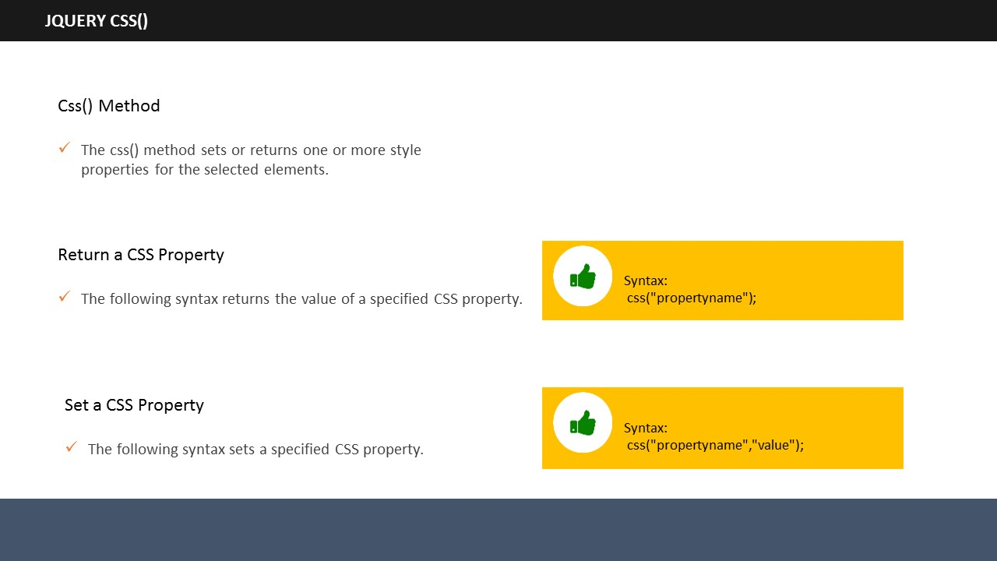

**SUBTOPIC 6: jQuery- CSS()**

**Say:**

jQuery allows you to set or get multiple style properties of selected elements. jQuery css() method helps you do that.

**Return a CSS property**

**Syntax:**

Css(“property name”);

**Say:**

Let us see an example which will return the background color value. Remember that it will return the value of only the first matched element.

**Example:**

<!DOCTYPE html>

<html>

<head>

<script src="https://ajax.googleapis.com/ajax/libs/jquery/1.11.3/jquery.min.js"></script>

<script>

$(document).ready(function(){

$("button").dblclick(function(){

alert("Background color = " + $("p").css("background-color"));

});

});

</script>

</head>

<body>

<h2>Heading Text</h2>

<p style="background-color:#00FF00">sample paragraph.</p>

<p style="background-color:#3366FF">sample paragraph.</p>

<p style="background-color:#CC99FF">sample paragraph.</p>

<button>Return background color of p</button>

</body>

</html>

**Say:**

The example returns the background color of the first paragraph, which was green. It returns the background color value of only green because it was the first matched element.

**Set multiple CSS properties**

**Say:**

You can set one or more CSS properties of elements in jQuery.

Syntax:

For setting one CSS property:

**css(“property name”, “value”);**

For setting multiple CSS properties:

**css({“property name” : “value”, “property name”: “value”,….});**

**Say:**

Let us see an example to understand it better.

**Example:**

<!DOCTYPE html>

<html>

<head>

<script src="https://ajax.googleapis.com/ajax/libs/jquery/1.11.3/jquery.min.js"></script>

<script>

$(document).ready(function(){

$("button").dblclick(function(){

$("p").css({"background-color": "green", "font-size": "150%"});

});

});

</script>

</head>

<body>

<h2> Heading Text</h2>

<p style="background-color:#00FF00">sample paragraph.</p>

<p style="background-color:#3366FF">sample paragraph.</p>

<p style="background-color:#CC99FF">sample paragraph.</p>

<p>Demo paragraph.</p>

<button>Set multiple styles for p</button>

</body>

</html>

**Say:**

In this example, the background color and the font size of all the ***<p>*** elements are changed. We have changed two values, you can change many more and all at the same time.

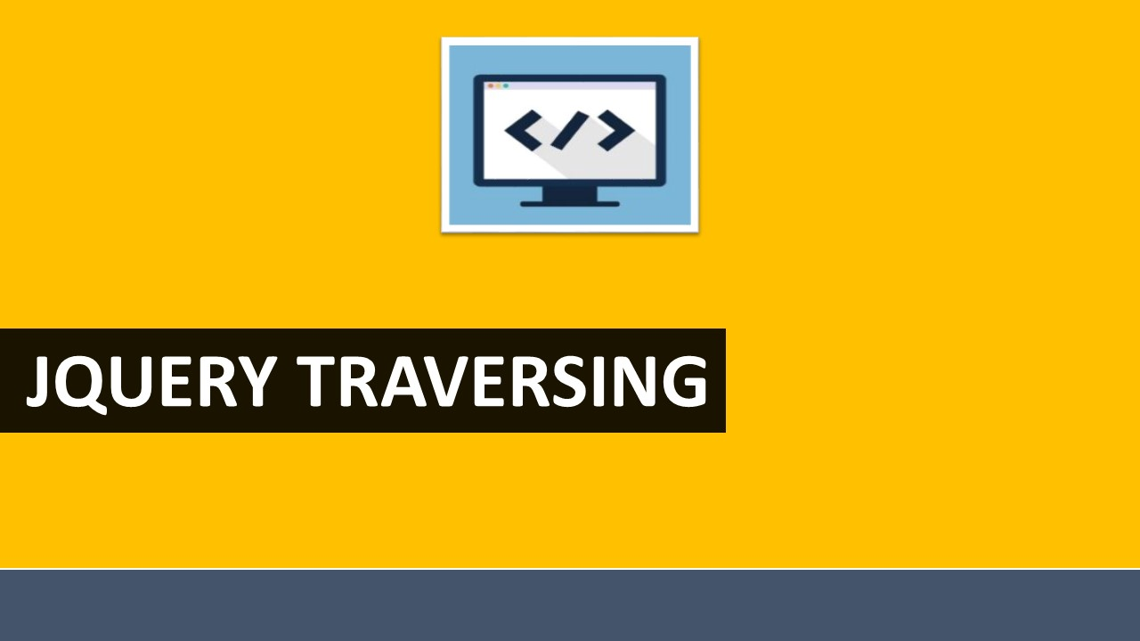

**TOPIC 3: jQuery Traversing**

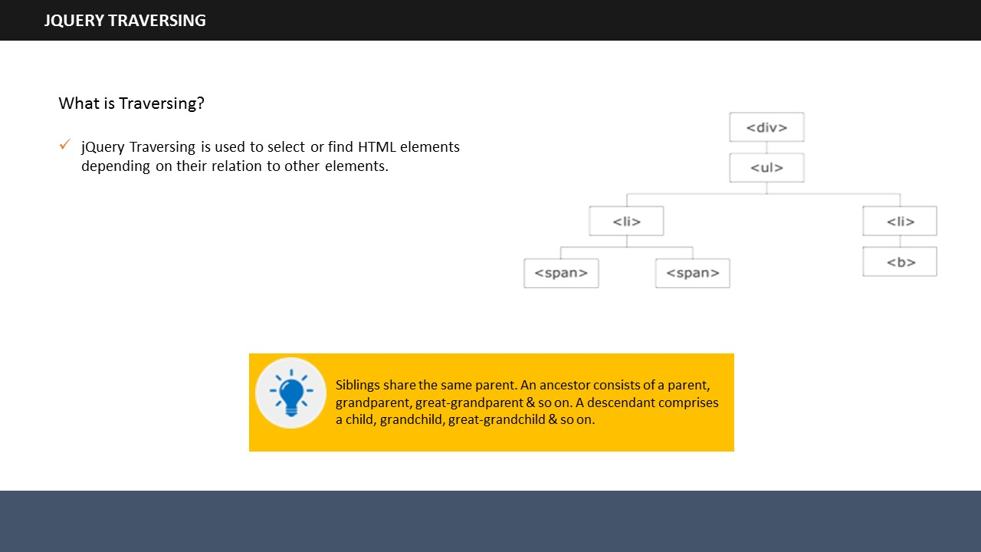

**SUBTOPIC 1: jQuery Traversing**

**Say:**

jQuery traversing is used to select or find HTML elements depending on their relation to other elements. It begins with one selection & move through until it reaches the desired elements.

**Say:**

Let us see an image to understand it better.

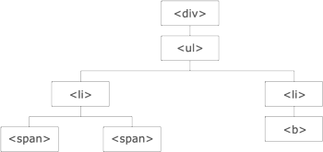

**Say:**

The ***<div>*** element is the parent of ***<ul>***& an ancestor of all elements inside it.

The ***<ul>*** element is the parent of both ***<li>*** elements, child of ***<div>,*** and descendant of***<div>.***

The left ***<li>*** element is the parent of both ***<span>***, child of ***<ul>*** and a descendant of ***<div>.***

The two ***<span>*** elements are children of the left ***<li>*** and descendants of ***<ul>*** and ***<div>.*** They both are siblings with each other as they share the same parent.

The two ***<li>*** elements are siblings as they share the same parent.

The right ***<li>*** element is the parent of ***<b>***, child of ***<ul>*** and a descendant of ***<div>.***

The ***<b>*** element is a child of the right ***<li>*** and a descendant of ***<ul>*** and ***<div>.***

* Siblings share the same parents
* An ancestor can be a parent, grand-parent, great-grand-parent and so on
* A descendant can be a child, grand-child, great grand-child,and so on

**Traversing the DOM**

**Say:**

jQuery provides numerous methods to traverse the Document Object Model (DOM). You can easily traverse up, down and sideways in DOM through tree traversal, which is the largest category of traversal methods.

**Some useful jQuery traversing methods**

|  |  |
| --- | --- |
| **add():** Add elements to the set of matched elements**:**  **addBack():** Adds the previous set of elements to the current set  **andSelf():** It is an alias for an addBack()  **children():** Returns all direct children  **closest():** Returns the first ancestor  **contents():** Returns all direct children  **each():** Executes a function for each matched element  **end():** Ends the most recent filtering operation in the current chain, and return the set of matched elements to previous state | **has():** Returns all elements that have on element inside them  **is():** Checks the set of matched elements against a selector/element/jQuery object, and return true if at least one of these elements matches the given arguments  **map()** : Passes each element in the matched set through a function, producing a new jQuery object containing the return values  **offsetParent():** Returns the first positioned parent element  **slice():** Reduces the set of matched elements to a subset specified by a range of indices |

**Say:**

Let us see how we can traverse in the DOM.

**SUBTOPIC 2: jQuery Ancestors**

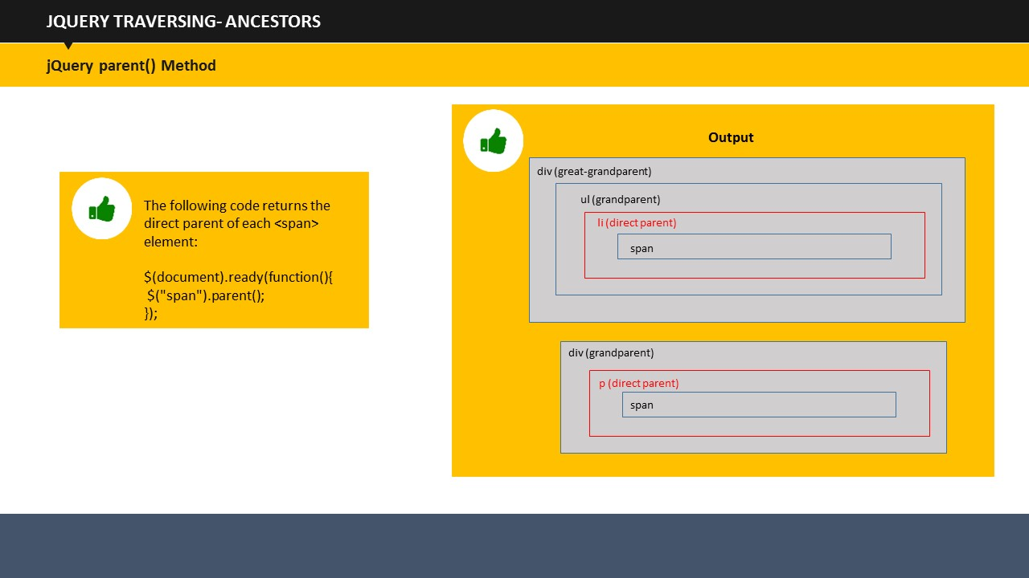**Say:**

As I have said, an ancestor can be a parent, grand-parent, great grand-parent and so on. You can make use of parent(), parents(), and parentsUntil() method to traverse up the DOM in order to find ancestors of an element. Let us have a look at each of them.

**jQuery parent() Method**

**Say:**

This method returns the immediate parent of the selected element. Since it deals only with direct parent, it only goes one level up of the selected element, and don’t go beyond it. Let us see an example.

**Example:**

<!DOCTYPE html>

<html>

<head>

<style>

.ancestors * {

display: block;

border: 1.5px solid lightgrey;

color: grey;

padding: 4px;

margin: 12px;

}

</style>

<script src="https://ajax.googleapis.com/ajax/libs/jquery/1.11.3/jquery.min.js"></script>

<script>

$(document).ready(function(){

$("span").parent().css({"color": "red", "border": "2px solid red"});

});

</script>

</head>

<body>

<div class="ancestors">

<div style="width:600px;">div (great-grandparent)

<ul>ul (grandparent)

<li>li (direct parent)

<span>span</span>

</li>

</ul>

</div>

<div style="width:600px;">div (grandparent)

<p>p (direct parent)

<span>span</span>

</p>

</div>

</div>

</body>

</html>

**Say:**

Here, we wanted to find the parent of span. So, what we did was we changed some CSS properties of the parent of ***<span>***, so that it would show up. We change its color and border color from normal to blue.

**jQuery parents() Method**

**Say:**

jQuery parents() method returns all the ancestor elements of the selected element. It traverses all through the root of the tree to find and return all ancestors. Let us see an example to understand it better.

**Example:**

<html>

<head>

<style>

.ancestors * {

display: block;

border: 1px solid lightgrey;

color: grey;

padding: 4px;

margin: 12px;

}

</style>

<script src="https://ajax.googleapis.com/ajax/libs/jquery/1.11.3/jquery.min.js"></script>

<script>

$(document).ready(function(){

$("span").parents().css({"color": "red", "border": "1.5px solid red"});

});

</script>

</head>

<body class="ancestors">body (great-great-grandparent)

<div style="width:600px;">div (great-grandparent)

<ul>ul (grandparent)

<li>li (direct parent)

<span>span</span>

</li>

</ul>

</div>

</body>

</html>

**Say:**

The following example would return ancestors of***<span>***elements. We have changed the CSS properties of all parents of ***<span>*** elements to make them stand out.

**jQuery parentsUntil() Method**

**Say:**

We have traversed direct parent; we have traversed all the ancestor elements. But what if we want to look for a parent only two levels up of the selected elements. For that, jQuery has aparentsUntil() Method. It returns ancestor elements between two arguments.

**Say:**

Let us see an example.

Example:

<!DOCTYPE html>

<html>

<head>

<style>

.ancestors * {

display: block;

border: 1px solid lightgrey;

color: grey;

padding: 4px;

margin: 12px;

}

</style>

<script src="https://ajax.googleapis.com/ajax/libs/jquery/1.11.3/jquery.min.js"></script>

<script>

$(document).ready(function(){

$("span").parentsUntil("body").css({"color": "red", "border": "1.5px solid red"});

});

</script>

</head>

<body class="ancestors"> body (great-great-grandparent)

<div style="width:600px;">div (great-grandparent)

<ul>ul (grandparent)

<li>li (direct parent)

<span>span</span>

</li>

</ul>

</div>

</body>

</html>

**Say:**

This example searches for all the parents of ***<span>*** from its immediate parent till the body. In this case, li, ul and, and div are the results of the code.

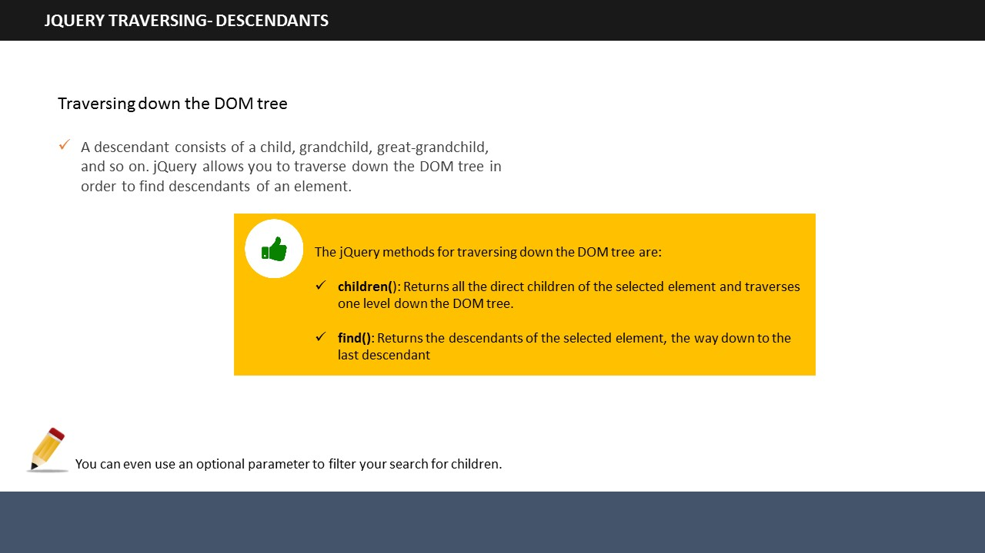

**SUBTOPIC 3: jQuery Descendants**

**Say**

As I have said, a descendant can be a child, grand-child, great-grandchild, and so on. You can make use of children() and find() Method to traverse down the DOM in order to find descendants of an element. Let us have a look at each of them.

**jQuery children() method**

**Say:**

Similar to parent() Method, children() Method also searches down only one level, and return the immediate children of the selected element. Let us see an example.

**Example:**

<!DOCTYPE html>

<html>

<head>

<style>

.descendants * {

display: block;

border: 1px solid lightgrey;

color: grey;

padding: 4px;

margin: 12px;

}

</style>

<script src="https://ajax.googleapis.com/ajax/libs/jquery/1.11.3/jquery.min.js"></script>

<script>

$(document).ready(function(){

$("div").children().css({"color": "red", "border": "1.5px solid red"});

});

</script>

</head>

<body>

<div class="descendants" style="width:500px;">div (current element)

<p>p (child)

<span>span (grandchild)</span>

</p>

<p>p (child)

<span>span (grandchild)</span>

</p>

</div>

</body>

</html>

**Say:**

This example returns the direct children of each of the ***<div>*** elements.

**Say:**

You can also filter the method to get a particular child.

**Example:**

<!DOCTYPE html>

<html>

<head>

<style>

.descendants * {

display: block;

border: 1px solid lightgrey;

color: grey;

padding: 4px;

margin: 12px;

}

</style>

<script src="https://ajax.googleapis.com/ajax/libs/jquery/1.11.3/jquery.min.js"></script>

<script>

$(document).ready(function(){

$("div").children("p.2").css({"color": "red", "border": "1.5px solid red"});

});

</script>

</head>

<body>

<div class="descendants" style="width:600px;">div (current element)

<p class="1">p (child)

<span>span (grandchild)</span>

</p>

<p class="2">p (child)

<span>span (grandchild)</span>

</p>

</div>

</body>

</html>

**Say:**

In this example, we have filtered our child search to get exactly what we wanted, and not anything else, as we got in the previous example.

**jQuery find() Method**

**Say:**

The find() method returns all the descendants of the selected element. It searches till the last descendant. Let us see an example.

**Example:**

<!DOCTYPE html>

<html>

<head>

<style>

.descendants * {

display: block;

border: 1px solid lightgrey;

color: grey;

padding: 4px;

margin: 12px;

}

</style>

<script src="https://ajax.googleapis.com/ajax/libs/jquery/1.11.3/jquery.min.js"></script>

<script>

$(document).ready(function(){

$("div").find("*").css({"color": "red", "border": "1.5px solid red"});

});

</script>

</head>

<body>

<div class="descendants" style="width:600px;">div (current element)

<p>p (child)

<span>span (grandchild)</span>

</p>

<p>p (child)

<span>span (grandchild)</span>

</p>

</div>

</body>

</html>

**Say:**

This example returns all the descendants of ***<div>***elements.

Say:

We can look for a particular descendant by changing the syntax a little. Let us see how.

**Example:**

**SUBTOPIC 4: jQuery Siblings**

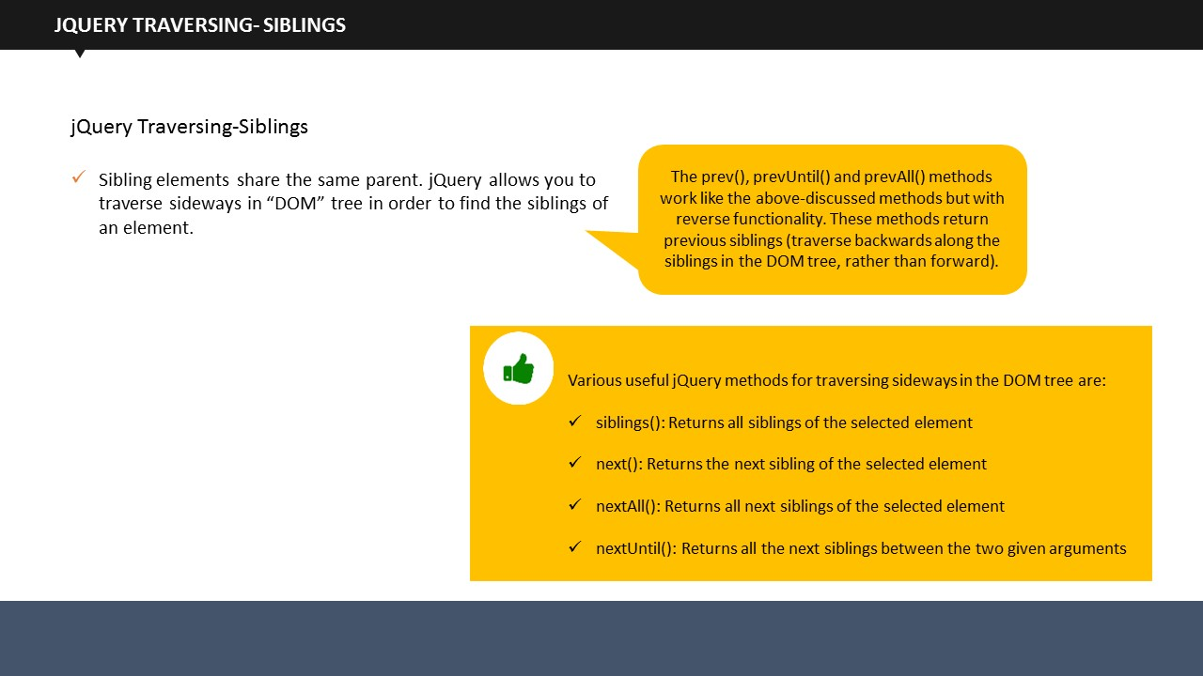$(document).ready(function(){

$("div").find("span").css({"color": "red", "border": "1.5px solid red"});

});

**Say:**

Instead of *, I wrote span. Initially the code was looking for all descendants of the ***<div>*** element, but with this modification, the program will return only **<span>** elements.

**Say:**

As I have said, siblings share the same parent.

**Say:**

So far, we have traversed up and down to find ancestors and descendants. Now we are going to traverse sideways to search for siblings.

**Say:**

jQuery has provided us a variety of methods to traverse for siblings. We can use siblings(), next(), nextAll(), nextUntil(), prev(), prevAll(), and prevUntil() Methods to traverse sideways in a DOM tree.let us have a look at each of them.

**jQuery siblings() Method**

**Say:**

Simplest of them all, jQuery siblings() return all siblings of selected element.

**Say:**

An example would clarify it better. Have a look.

**Example:**

<!DOCTYPE html>

<html>

<head>

<style>

.siblings * {

display: block;

border: 1px solid lightgrey;

color: grey;

padding: 4px;

margin: 12px;

}

</style>

<script src="https://ajax.googleapis.com/ajax/libs/jquery/1.11.3/jquery.min.js"></script>

<script>

$(document).ready(function(){

$("h2").siblings().css({"color": "red", "border": "1.5px solid red"});

});

</script>

</head>

<body class="siblings">

<div>div (parent)

<p>p</p>

<span>span</span>

<h2>h2</h2>

<h3>h3</h3>

<p>p</p>

</div>

</body>

</html>

**Say:**

This example returns all siblings of <h2>.

**jQuery next()**

jQuery next() Method, as the name suggests, returns the next sibling of the selected element. Let us see an example.

**Example:**

$(document).ready(function(){

$("h2").next().css({"color": "red", "border": "1.5px solid red"});

});

**Say:**

Rest of the code is similar to the previous example. The only change is the usage of next() Method in place of siblings() Method. This code will return only the next sibling of <h2>.

**jQuery nextAll()**

**Say:**

jQuerynextAll() Method returns all next siblings of the selected element.

**Example:**

$(document).ready(function(){

$("h2").nextAll().css({"color": "red", "border": "1.5px solid red"});

});

**Say:**

Rest of the code remains the same, except the method. The nextAll() method here returns all the next elements of ***<h2>***.

**jQuery nextUntil()**

**Say:**

The jQuery nextUntil() Method returns all the sibling elements between two given arguments.

**Example:**

<!DOCTYPE html>

<html>

<head>

<style>

.siblings * {

display: block;

border: 1px solid lightgrey;

color: grey;

padding: 4px;

margin: 12px;

}

</style>

<script src="https://ajax.googleapis.com/ajax/libs/jquery/1.11.3/jquery.min.js"></script>

<script>

$(document).ready(function(){

$("h2").nextUntil("h6").css({"color": "red", "border": "2px solid red"});

});

</script>

</head>

<body class="siblings">

<div>div (parent)

<p>p</p>

<span>span</span>

<h2>h2</h2>

<h3>h3</h3>

<h4>h4</h4>

<h5>h5</h5>

<h6>h6</h6>

<p>p</p>

</div>

</body>

</html>

**Say:**

The nextUntil() Method will display all the sibling elements between ***<h2>*** and ***<h6>***. So, the final output which you can see on screen is ***<h3>***, ***<h4>*** and ***<h5>*** being colored in red.

The prev(), prevAll(), and prevUntil() Methods work the same way as next(), nextAll(), and nextUntil(), except that they work in reverse functionality. In short, they traverse backwards in the Dom tree rather than forward.

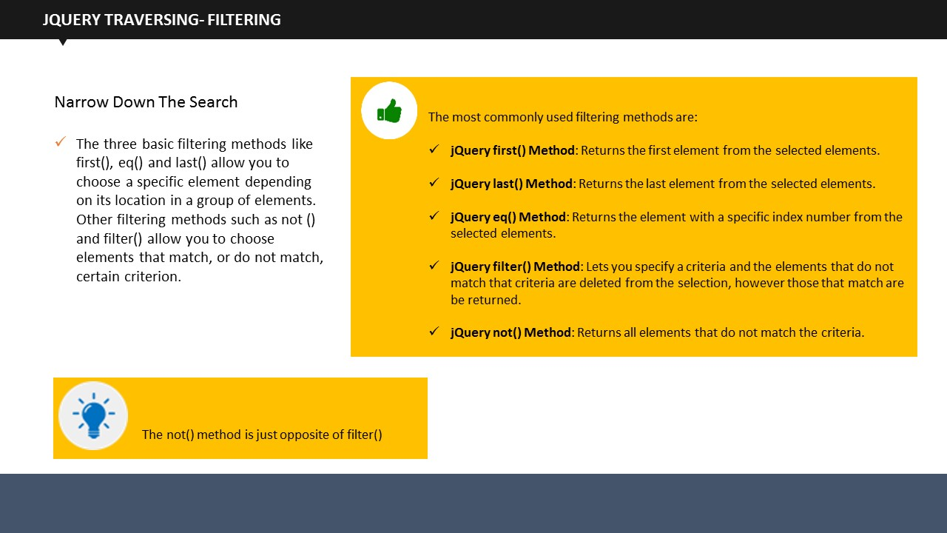**Say:**

**SUBTOPIC 5: jQuery Filtering**

jQuery provides three basic filtering methods, which are first(), last(), and eq(). They allow you to select particular elements basis on their positions within the group of elements.

**Say:**

Other methods namely filter() and not() are used to select elements which either match or do not match a specific criteria.

**jQuery first() Method**

**Say:**

The jQueryfirst() method selects the first element among the selected elements. Let us see an example.

**Example:**

<!DOCTYPE html>

<html>

<head>

<script src="https://ajax.googleapis.com/ajax/libs/jquery/1.11.3/jquery.min.js"></script>

<script>

$(document).ready(function(){

$("div p").first().css("background-color", "yellow");

});

</script>

</head>

<body>

<h1>This is my homepage</h1>

<p>This is a demo paragraph in body.</p>

<div style="border: 1px solid black;">

<p>This is a demo paragraph in a div.</p>

<p>This is another demo paragraph in a div.</p>

</div><br>

<div style="border: 2px solid black;">

<p>This is the a demo paragraph in another div.</p>

<p>This is another demo paragraph in another div.</p>

</div>

<p>This is the final paragraph in body.</p>

</body>

</html>

**Say:**

We take two ***<div>***elements within a body. Both contain some paragraphs. Our code searches for the first ***<p>*** element of the first ***<div>***, and display the same in the output.

**jQuery last()**

**Say:**

Similar to first() Method, last() Method returns the last elements among selected elements. Let us take the same example which we just taken for the first() Method.

**Example:**

$(document).ready(function(){

$("div p").last().css("background-color", "yellow");

});

**Say:**

Rest of the code is same, only the Method is changed. The output of this program returns the last ***<p>*** element of the last ***<div>***.

**jQuery eq() Method**

**Say:**

jQuery eq() Method returns the index number of the selected element.

* First element holds an index value of 0, and not 1

**Say:**

Let us take an example.

**Example:**

<!DOCTYPE html>

<html>

<head>

<script src="https://ajax.googleapis.com/ajax/libs/jquery/1.11.3/jquery.min.js"></script>

<script>

$(document).ready(function(){

$("p").eq(2).css("background-color", "yellow");

});

</script>

</head>

<body>

<h1>This is my homepage</h1>

<p>I am Donald (index 0).</p>

<p>Donald Darwin (index 1).</p>

<p>I live in Dhaka (index 2).</p>

<p>I love Cricket a lot (index 3).</p>

</body>

</html>

**Say:**

In this example, we filtered the given text for index value 2. When the code runs, the ***<p>***element with an index value 2 will be highlighted. In this case, it is “I live in Dhaka”, which is being highlighted, as you can see.

**jQuery filter() Method**

**Say:**

The jQuery filter() Method allows web developers to filter elements based on a criteria. If the elements match the criteria, they are returned, and those that don’t, they are removed from selection. Let us see an example.

**Example:**

<!DOCTYPE html>

<html>

<head>

<script src="https://ajax.googleapis.com/ajax/libs/jquery/1.11.3/jquery.min.js"></script>

<script>

$(document).ready(function(){

$("p").filter(".introduce").css("background-color", "yellow");

});

</script>

</head>

<body>

<h1>This is Homepage</h1>

<p>My name is Darwin.</p>

<p class="introduce">I live in Dhaka.</p>

<p>I love Dhaka.</p>

<p class="introduce">I love cricket a lot.</p>

</body>

</html>

</body>

</html>

**Say:**

In this example, we filtered the ***<h>*** and the ***<p>*** elements for class “introduce”, and changed the background- color of those that matched the criteria. Only two ***<p>*** elements matched and they are displayed, while rest of them were removed from selection.

**jQuery not() Method**

In contrast to the filter() Method(), the not() Method returns those values that do not match the criteria while removing those that do. Let us see an example.

**Example:**

$(document).ready(function(){

$("p").filter(".introduce").css("background-color", "yellow");

});

**Say:**

If we look at the previous example, if we write not() instead of filter() in there, we get “My name is Darwin” and “I love Dhaka” as output.

**TOPIC 5: Summary**

**Say:**

**SUBTOPIC 1: Recap**

In this topic, we learned that:

1. jQueryis a JavaScript library that makes it much easier to use JavaScript on your Website while solving cross-browser problems.
2. The jQuery Selectors help you to select and modify HTML elements based on their id, classes, types, attributes, values of attributes, and much more.
3. The jQuery Events are the different visitor actions that a Web page can reply to.
4. The jQuery Hide/Show methods are used to hide and show elements and the jQuery fade() method allows you to fade elements.
5. The jQuery slide() method slides elements up and down and the jQuery animate() method is used to create custom animations.
6. When an effect is applied to some lines of code, the jQuery Callback function helps a specific line to run After the effect is finished, thus preventing error.
7. The jQuery Chaining Method allows you to run multiple commands sequentially.
8. The jQuery Get Content function includes text(), html(), and val() Methods.
9. The jQuery Add function includes append(), prepend(), and After() and before() Methods.
10. The jQuery Remove function has remove(), empty(), and Filter the elements to be removed Methods.
11. The jQuery CSS Classes function has addClass(), removeClass(), and toggleClass() Methods.
12. jQuery Traversing is used to select or find HTML elements depending on their relation to other elements.
13. jQuery Traversing includes Ancestor, Descendant, Sibling, and Filtering Methods.

## 

**SUBTOPIC 2: Final Tips and Summarization**

**Say:** This is the end of session. I hope you understood the concepts that we covered today and would be able to use them as a base to understand details of jQuery.

**Do:**

Use this moment to clarify any doubts and provide any tips to the learners.

# Topic 6: Check Your Understanding

1. What is the basic jQuery syntax?
2. $(hide).action();
3. $(selector).action()
4. $(selector)#test()
5. $(selector)action()
6. How will you find elements with a specific class?
7. Write a hash character followed by the name of the function.
8. Write a colon character followed by the name of the object.
9. Write a period character followed by the name of the class.
10. Write a period character followed by the name of the document.
11. What is the function of $(document).ready() method?
12. The $(document).ready() method lets us execute a function when the document is completely loaded.
13. The $(document).ready() method allows us to write a function After the document is executed.
14. The $(document).ready() method executes a completely loaded document.
15. The $(document).ready() method allows us to write the dblclick() method.
16. What is the jQuery toggle() method?
17. $(click).toggle(*speed,callback*);
18. $(*selector*).toggle(*hide,callback*);
19. $(*ready*).toggle(*speed,callback*);
20. $(*selector*).toggle(*speed,callback*);
21. Name the method which fades out a visible element.
22. fadeIn() method
23. fadeOut() method
24. fadeToggle() method
25. fadeTo() method
26. The functionality of Callback function is:
27. A callback function helps to run a multiple lines of code when its effect is finished.
28. A callback function helps to run a specific line of code when its effect is finished.
29. A callback function helps to run a two lines of code when its effect is finished.
30. A callback function helps to run a line of code when its effect is not finished.
31. Which Get Content method sets or returns the text content of selected elements?
32. Text()
33. Html()
34. Val()
35. The callback function for attr() method has two parameters:
36. The class of the current element & the original object value.
37. The index of the current element & the original object value.
38. The directory of the current attribute & the original element value.
39. What is the syntax of returning a CSS property?
40. css("*propertyid*");
41. css("*propertyvalue*");
42. css("*propertynumber*");
43. css("*propertyname*");
44. What are the three jQuery methods for traversing up the DOM tree?
45. parent()
46. siblings()
47. parents()
48. parentsUntil()
49. Which jQuery method returns all next siblings of the selected element for traversing sideways in the DOM tree?
50. siblings()
51. next()
52. nextAll()
53. nextUntil()
54. Which jQuery filtering method returns the element with a specific index number from the selected elements?
55. jQuery first() Method
56. jQuery last() Method
57. jQuery eq() Method
58. jQuery not() Method



**ITES Functional Skills Training**

# LAB EXERCISES

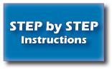

* You may want to bring your FacilitatorGuide to labs to refer to the content and examples.
* If the participants have a question, tell them that they can ask you for help, or look at their ParticipantGuide or lecture slides.
* Encourage the participants to talk to their classmates; tell them it is okay to share code and ideas during lab.
* Tell the participants that they are not expected to finish all the exercises. They simply need to do as much as they can in the allotted time. They don't need to finish the rest After they leave the lab.
* Before they leave, tell them to check in with you to get credit for their work.

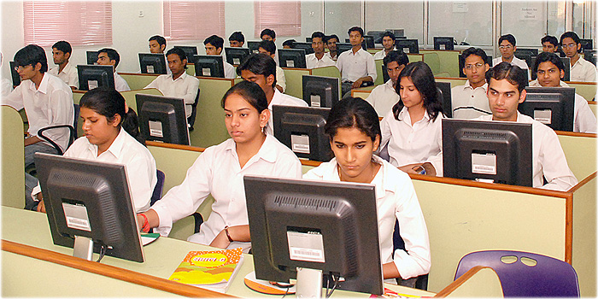

**Exercise 1:Toggle between hiding & showing the <p> element when you click on the "Toggle" button.**

**Edit this code:**

<!DOCTYPE html>

<html>

<head>

<script src="http://ajax.googleapis.com/ajax/libs/jquery/1.11.3/jquery.min.js"></script>

<script>

$(document).ready(function(){

$("button").click(function(){

$("p").method();

});

});

</script>

</head>

<body>

<button>Toggle</button>

<p>This is a paragraph.</p>

</body>

</html>

**Say:**

You need to edit this code to insert correct method. Write the correct code in your guide, and then perform the program on your system and see what the output is.

**Exercise 2: When the mouse pointer enters the *<span>* element, it should be hidden. Use the correct event to do so.**

**Edit this code:**

<!DOCTYPE html>

<html>

<head>

<script src="http://ajax.googleapis.com/ajax/libs/jquery/1.11.3/jquery.min.js"></script>

<script>

$(document).ready(function(){

$("selector").event(function(){

$(this).hide();

});

});

</script>

</head>

<body>

<span>If you mouse over me, I will disappear.</span><br>

<span>If you mouse over me, I will disappear.</span>

</body>

</html>

**Say:** You need to edit this code to insert correct the corrcet event. Write the correct code in your guide, and then perform the program on your system and see what the output is.

**Exercise 3: Write a program to add a blue color to all sibling elements between <h2> and <h6>.**

**Hint:** Use the nextUntil() method.

**Say:**

Use the given hint to write a program to add color to all sibling elements between ***<h2>*** and ***<h6>***.

**Exercise 4: Write a program to set the font-size of *<div>* to 100 pixels using the animate() method. The duration of the effect should be "slow".**

**Hint:**  $("element").animate({property:"value"},speed);

**Say:**

Use the given hint to write a program to set the font-size of ***<div>*** to 100 pixels using the animate() method. Make sure that the animation remains slow.

**Exercise 5: Write a program to add a red color to third *<p>* element.**

**Hint:** Use the eq() method, and remember that index numbers start at 0.

**Say:**

You need to write a program to add a red color to third **<p>** element. Make sure that you remember that index numbers begin from 0.

**Do:**

After the students are done with their exercises:

**Say:**Great work!

**Do:**

Now, review their work and give relevant feedback.

**Note:** Discuss the concept and output with the students when they are done with the exercise. Ask them to share their views on what they have observed. Give them diagnostic feedback. Help them resolve their queries.